Understand with Cabri 3D dynamic geometry how coordinates equations and geometry interconnect

T3 2009 Seattle, February 2009

Colette Laborde
University Joseph Fourier,
Grenoble, France
Colette.Laborde@imag.fr

Session presented by

Kate Mackrell
Institute of Education,
University of London, UK
katemackrell@sympatico.ca

Abstract
Participants will experience hands-on activities for high school or college students in the dynamic geometry environment Cabri 3D that are meant for linking coordinates and equations to geometric objects. One of the aims of the activities is to help students understand through dragging how the behavior of geometric objects is affected by changes in equations or coordinates.

A. How the point of intersection of a plane with the z axis affects its equation

Setting up the file
Create the line supporting the z vector.

Create points (2,0,0) and (0,2,0) and a point P on the line supporting the blue vector (z axis).

Create the plane passing through each of these points.
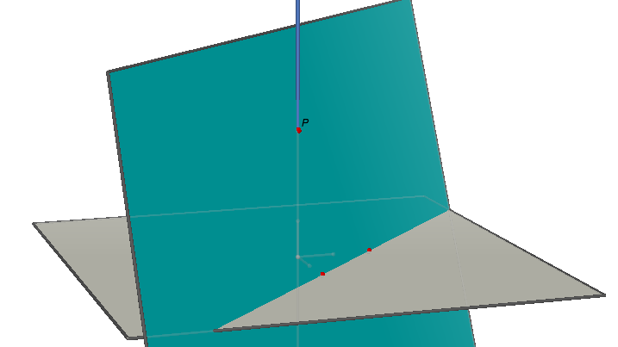

Display the equation of the plane (Tool Coord.&equations)

The equation is of the type:
x + y + c z = 2

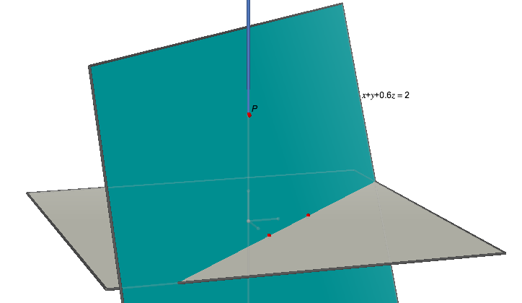

This file may be downloaded from
http://idisk.mac.com/katemackrell-Public/Cabri3D/CLfile1.cg3

The Activity
1.Move point P on the z-axis. What is changing in the equation of the plane? Justify why.

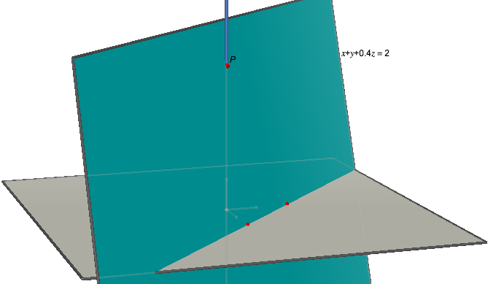

2. Display the coordinates of point P. Move point P until its z coordinate is 4.
The equation of the plane is now x + y + 0.5 z = 2

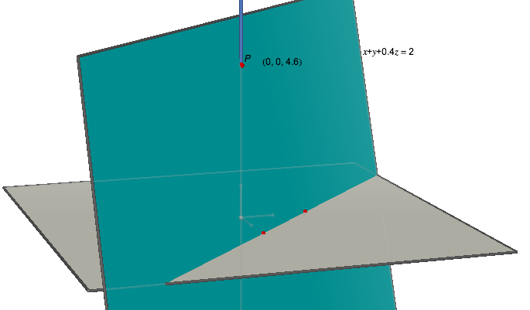

3. Hide the equation of the plane.
Move point P in order to be sure to obtain the plane with equation x + y + z = 2

Then check your answer by displaying the equation of the plane in its new position.

4. Predict the location of P to get the equation x + y – 2z = 2. Move P to this location to check your conjecture.

5. Change the location of the points on the x and y axes to (3,0,0) and (0,3,0) and repeat.

Where do points need to be placed on the x, y and z axes to get the equation of the plane x + y +5z = 4?

B. How to obtain the equation of a plane from the coordinates of its x, y and z intercepts

Setting up the file
3. Create the three lines supporting the x, y and z vectors. Create point P on the x line, Q on the y line, R on the z line.

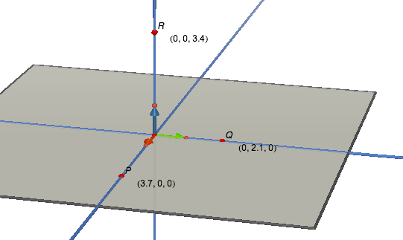

Display the coordinates of these points. Create the plane passing through points P, Q and R.

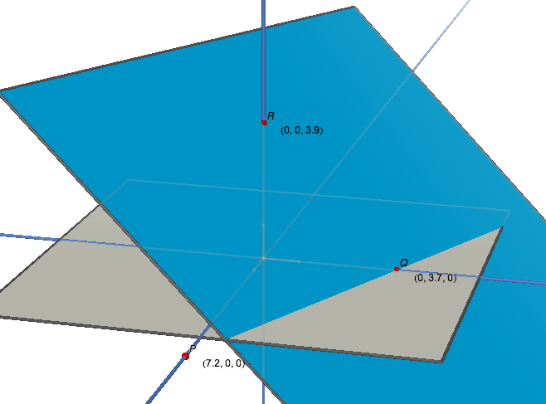

Display its equation.

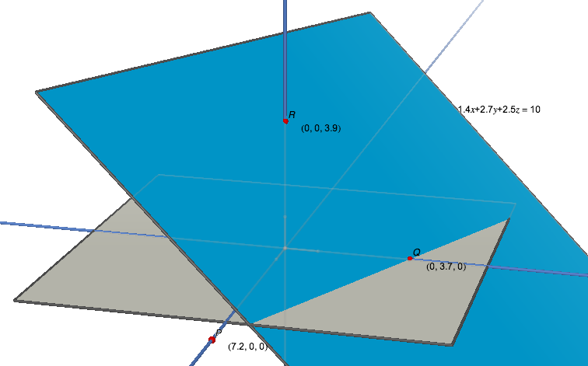

This file may be downloaded from
http://idisk.mac.com/katemackrell-Public/Cabri3D/CLfile2.cg3

The Activity
1. Move each of the points P, Q and R until its non-zero coordinate is equal to (5,0). The equation of the plane should be
2.0 x + 2.0 y + 2.0 z = 10
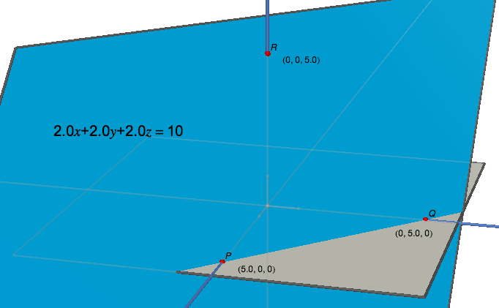

2. Move point P until the equation of the plane becomes 4.0x + 2.0y + 2.0z = 10. What is the x coordinate of P now?

Move point P until the equation of the plane is 5.0x + 2.0y + 2.0z = 10.
What is the x coordinate of P now?

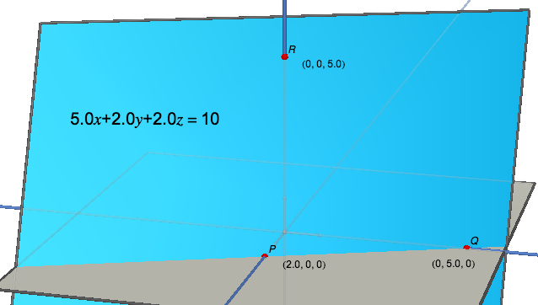

3. Repeat the same experiment with Q and R.
What is the equation of a plane passing through (a, 0, 0), (0, b, 0) and (0, 0, c)?

Calculate the coefficients of x, y and z in the equation of the plane by using the calculator of Cabri 3D and check your calculation with the displayed equation of the plane.

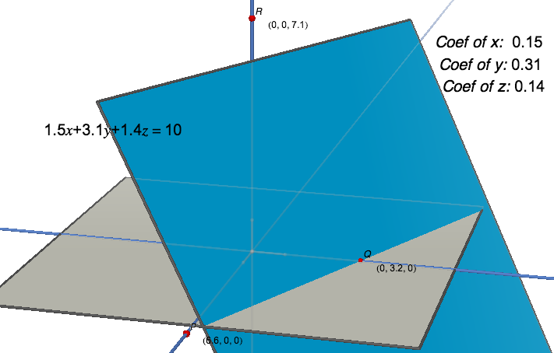

4. Very often, Cabri 3D gives the equation of a line in the form

dx + ey + fz = 10

In the previous section you saw one of the exceptions to this. Compare your results for the two sections.

What are the intercepts for a plane with equation

dx + ey + fz = g ?

C. Geometric relationships between two planes with some opposite coefficients in their equation

Setting up the file
Construct the plane with equation
x + y + z = 1 using only the geometric tools of Cabri 3D.

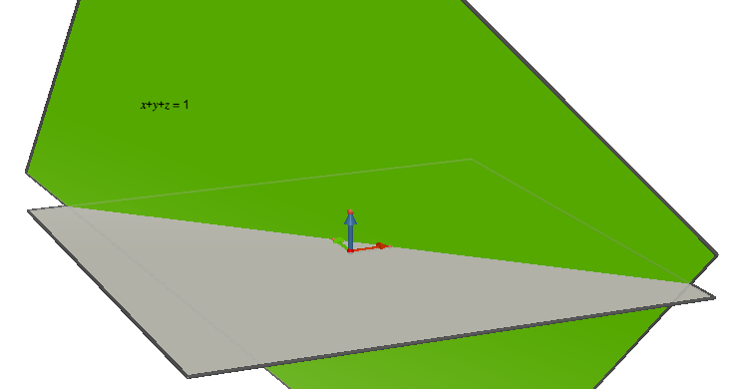

This file may be downloaded from
http://idisk.mac.com/katemackrell-Public/Cabri3D/CLfile3.cg3

The Activity
1. By using the transformation tools, construct the plane with equation x – y + z = 1 as the image of the previous plane.
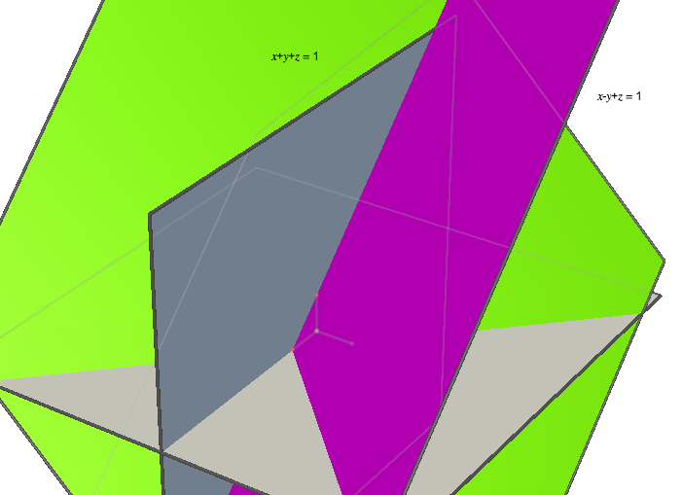

2. Obtain directly the plane with equation x – y - z = 1 as the image of the previous plane in a transformation.
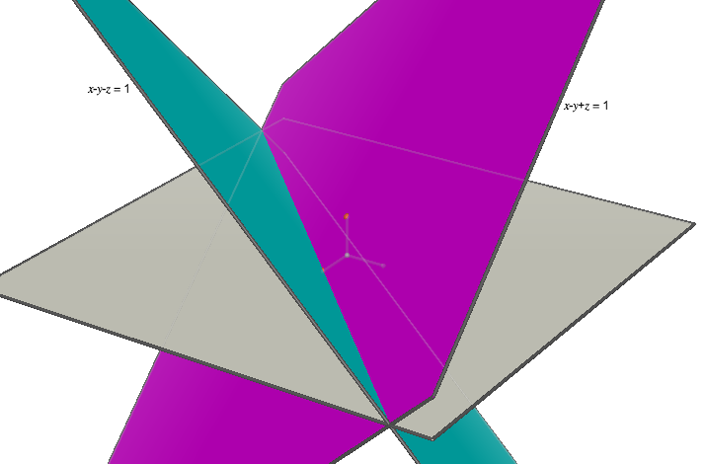

3. What transformation will create the plane with equation x – y –z = 1 from the plane x + y + z = 1 ?
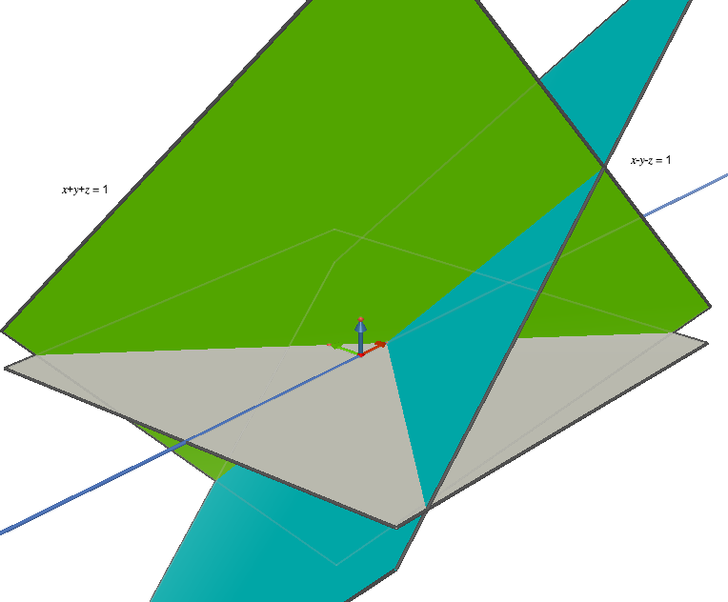

4. Explore the effects of translation on the equations of a plane.

D. Perpendiculars to a Plane
Download this file:
http://idisk.mac.com/katemackrell-Public/Cabri3D/CLfile4.cg3

Explore the components of vector V on the perpendicular to the plane as point V changes. Why does this happen?

