Modelling the Earth’s Rotation

Kate Mackrell, February 2009
katemackrell@sympatico.ca

We know that a sphere is rotating when markings on its surface are rotating.

Cabri 3D is designed, however, so that points on the surface of a sphere retain their orientation relative to the centre of the sphere. This has the consequence that such points appear to be stationary as the sphere rotates.

In order to give the appearance of rotation, we must hence rotate the markings on a sphere rather than the sphere itself.

1. Start by hiding the base vectors and origin (never delete these – you may need them later) so that only the base plane is visible:
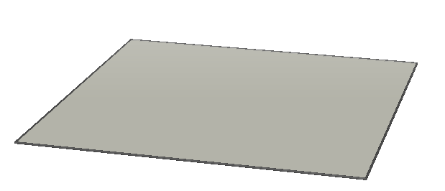

2. Now use the Sphere tool to create a sphere to represent the Earth:
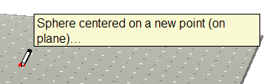

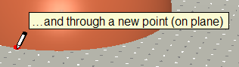

You want to end up with a fairly large sphere:
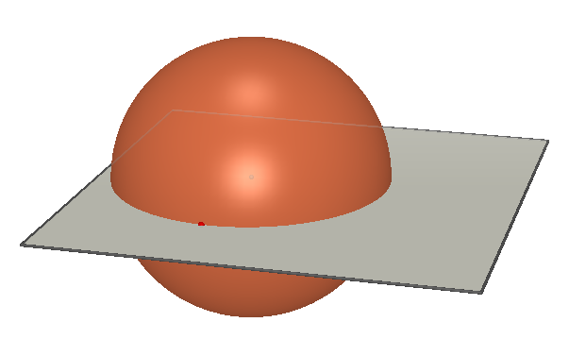

3. We have forgotten to label the centre and radius points! Select the Manipulation tool, click on the centre point and type CENTRE. Now click on the radius point and type R. Because the sphere is so large, you may not be able to see the centre label clearly: however Cabri will now refer to this point as CENTRE, which will be very helpful!
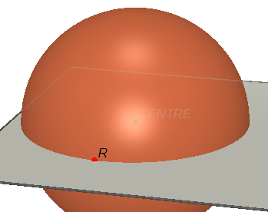

4. Now let’s use the Line tool to create an axis for the earth. Construct a line through point CENTRE and through a new point anywhere on the surface of the sphere.
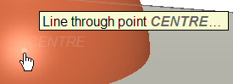

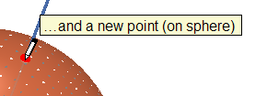

Type N to label this new point: it represents the North Pole.
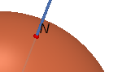

5. Right-click and drag to change the view angle so that you can see the intersection between this line and the opposite side of the sphere. Use the Point tool to create the point at this intersection and label it S for south pole.
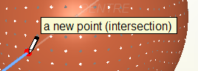



6. Let’s now hide the base plane, and the point R and change the orientation so that the axis is roughly vertical on the screen with points N and S both visible.
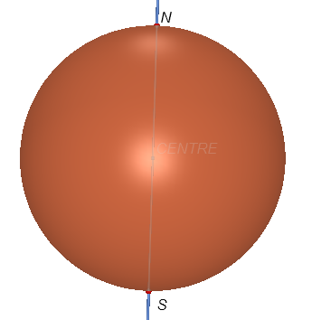

7. Now let’s create the equator by first using the Perpendicular tool to create a plane perpendicular to the axis passing through the centre.
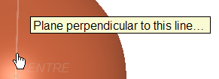

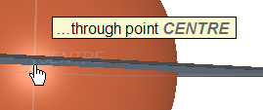

8. The Circle (or Intersection Curve) tool may now be used to construct the circle at the intersection between the plane and the sphere.
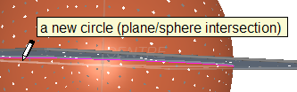

Now hide the plane. This circle represents the location of the equator.
9. However, we’re not going to use it as the equator. What follows is a bit of a sneaky trick so that we can put a point on the earth’s surface by dragging its latitude and longitude – and have it maintain its relative position as the Earth “rotates”. If all you want to do is to put on some circles of latitude and longitude, you can use this circle as the equator.
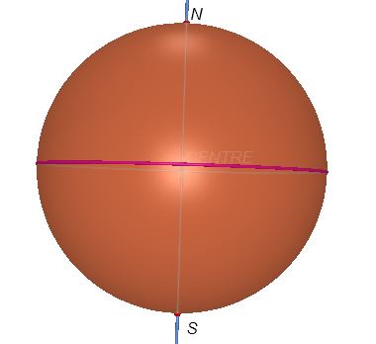

10. First of all, create a point on this circle using the Point tool (you may need to change the view angle slightly to be able to select the circle):
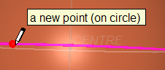

Label this point 0. It will represent the place where the Greenwich meridian intersects the equator.
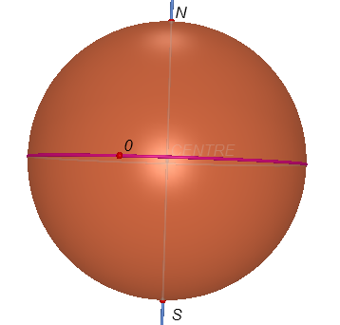

11. We will now hide the original circle and use the Circle tool to construct a new circle around the axis passing through 0.
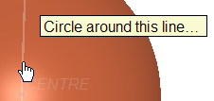

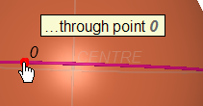

12. The new circle looks identical to the old circle! But it has an important new property. Use the Point tool to place a new point on the circle, and label this point LONG (it will represent the longitude of a location on earth.
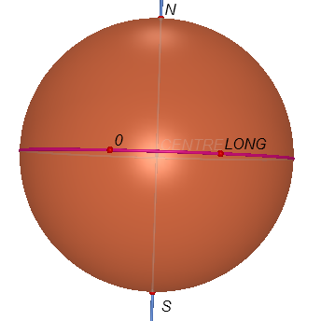

13. Now select the Manipulation tool and drag point 0: point LONG will also move around the circle, and in fact moves so that the angle between the central axis and the two points is constant. This does not happen if we use the original circle as equator.
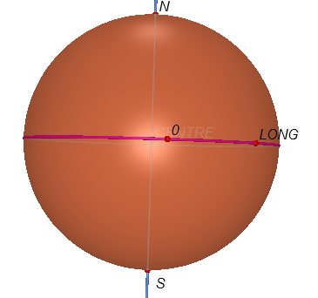

14. We’re now going to create the greatcircle of 0 longitude, by using the Circle tool to construct a circle through N, 0, and S.
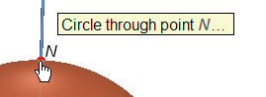

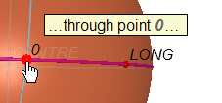

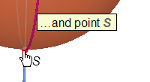

If you just want to put circles for latitude and longitude on the Earth, then delete point LONG and go to step 23.
15. Now use the Point tool to construct a point on the new circle and label this point LAT.
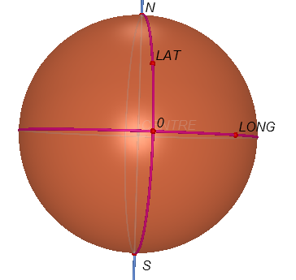

16. We will now construct two more circles, one around the axis passing through LAT and one passing through N, LONG and S:
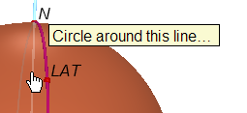

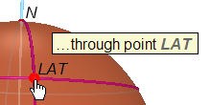

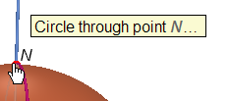

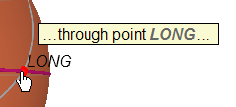

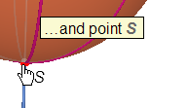

17. The intersections of these two circles will represent particular locations on the earth’s surface. Use the Point tool to place a point at the intersection that is visible.
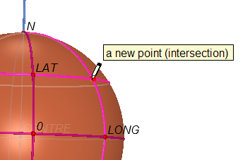

18. Let’s now use the Angle tool to measure the latitude and longitude of this point.
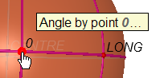

It’s difficult to select the centre from this view angle, so let’s change it. You can always do this partway through using a tool by right-clicking, holding down and dragging.
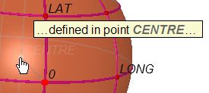

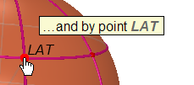

19. The result may not be visible. You can change the appearance of the sphere using the Styles panel or right-click contextual menu. Alternatively, you can use the Manipulation tool and move the mouse until the message “this angle” appears.
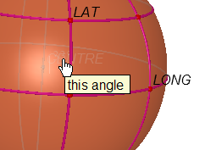

Now click, hold down and drag the measurement outside the sphere. Note that the angle is also given by a mark – if nothing drags out, try a slightly different location where “this angle” shows.
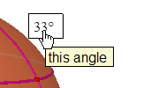

Click just before the first number and type “Latitude = “
20. Repeat to obtain the angle which measures the longitude.
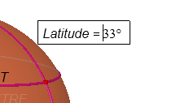

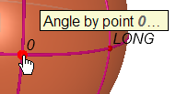

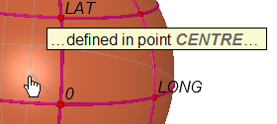

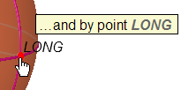

Drag this angle out of the sphere and label it ‘Longitude”.
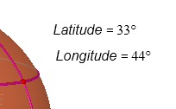

Note: this does not give the direction of latitude or longitude.
21. We’ll now move this point so that it represents Seattle, with latitude 47.6 N and longitude 122.3 W. Select the Manipulation tool and drag the points LAT and LONG. You may now click on the point and label it “SEATTLE”.
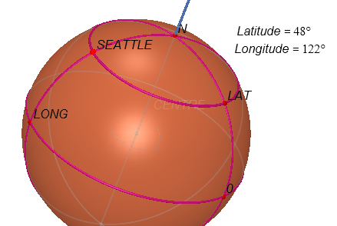

22. Now animate point 0. You will see the earth apparently rotate. If you drag point N, then the axis of apparent rotation will change.
23. We will next add some circles of latitude and longitude. Everything apart from these circles and points is hidden in what follows:
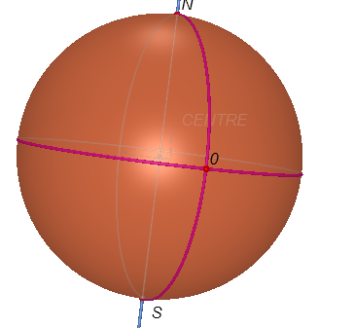

First of all, use the Calculator tool to enter the angle that you want between circles:
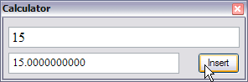

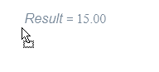
Click to position this on the screen.

24. We will now use the Rotation tool to rotate the greatcircle through N, 0 and S by this angle.
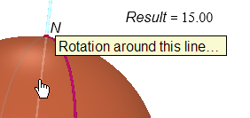

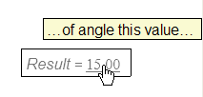

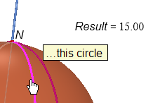

Now repeat this with the new circle, and continue to repeat until you have a ring of lines of longitude.
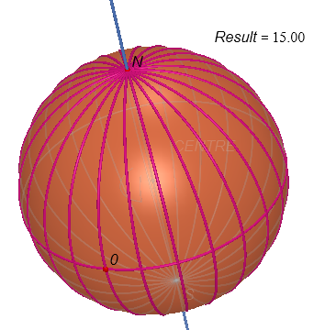

25. Circles of latitude aren’t quite as straightforward, however, as they aren’t greatcircles.
To create these, first use the Point tool to create the point where the 90 degree circle of longitude crosses the equator. Label this point 90 E (or 90 W).
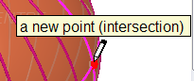

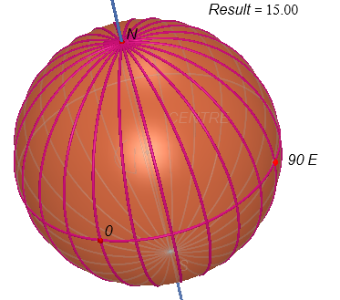

26. Now use the Line tool to create a line through this point and the centre of the sphere.
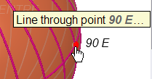

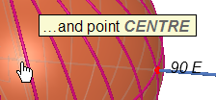

27. This line will serve as an axis of rotation, allowing us to create the points at which the circles of latitude will pass through the original circle of longitude through point 0. Select the Rotation tool.
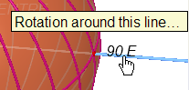

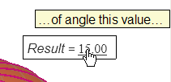

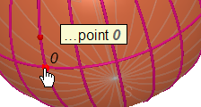

Now repeat this for the new point which has appeared:
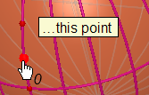

Repeat again until you have a set of points stretching from 0 to N.
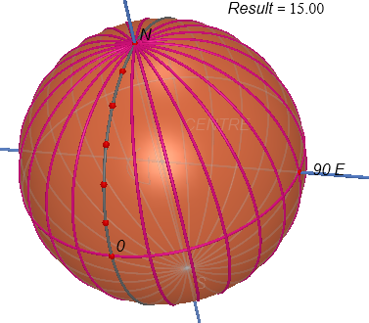
The greatcircle through 0 has been coloured gray so that the points are more visible.

28. Now use the Circle tool to create circles around the N-S axis through each of these points:
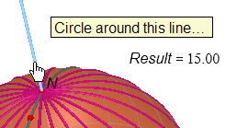

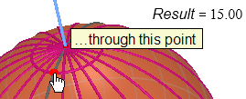

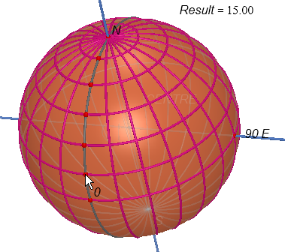

29. We could repeat this for the bottom half of the sphere, but a shortcut is to use the Half-Turn tool and reflect each circle in the line through 90 E.
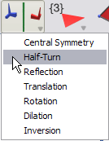

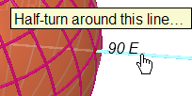

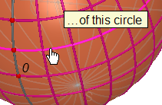

Repeat this for the other circles of latitude.
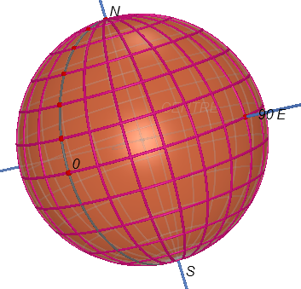

Now drag or animate point 0 to see the Earth rotate.

