Modelling the Seasons 1

Kate Mackrell, February 2009
katemackrell@sympatico.ca

This first model is designed to give a qualitative idea of the amount of daylight at different times of the year.

1. We will start by using the Sphere tool to create a sphere centred at the origin to represent the Sun. The relative size of the Sun is unimportant. Now use the Circle tool to create a circle around the origin in the base plane to represent the earth’s orbit and the Segment tool to create a segment to give the radius of the earth.
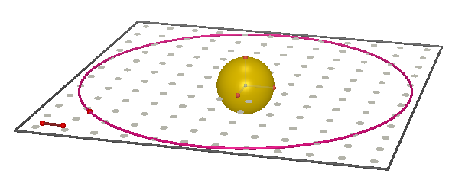

2. Let’s next use the Sphere tool to create a sphere to represent the Earth, with centre a new point on the circle.
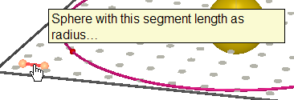

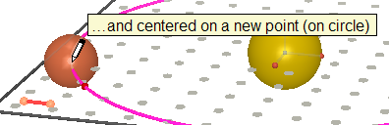
DO NOT CLICK ON THE RADIUS POINT

Type to label this point E immediately after clicking.
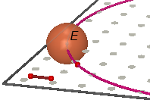

3. A critical factor in the seasons is the inclination of the earth’s axis. Let’s draw some lines to both give some orientation and to model this inclination. First, use the Line tool to construct the supporting lines for each of the base vectors:
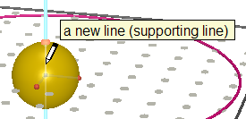

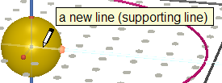

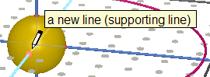

4. Next, use the Circle tool as follows:
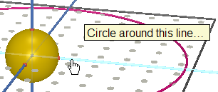

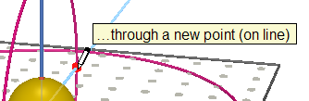

5. We will next use the Line tool to create a line through the centre of the sun and a new point on this circle.
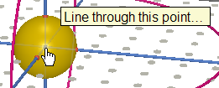

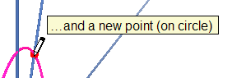

6. We will now use the Parallel tool to put a line parallel to this line through the centre of the earth.
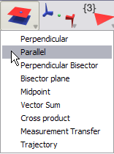

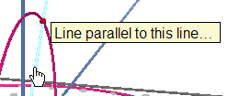

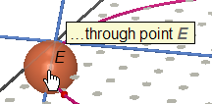

7. This line represents the earth’s axis. Let’s use the Angle tool to measure the axial tilt.
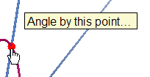

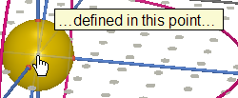

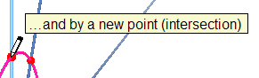

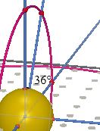

If you now drag or animate the Earth to move around the sun, you will see that its axis always points in the same direction. You can drag the point on the circle to change the angle.
8. Let’s now construct the Earth’s equator. We will first use the Perpendicular tool to construct a plane perpendicular to the axis passing through the centre of the Earth:
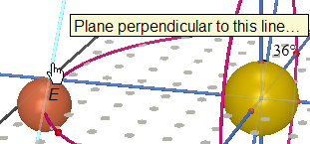

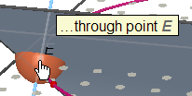

9. Now use the Circle tool (or the Intersection Curve tool) to construct the circle where this plane intersects the sphere.
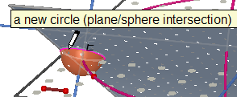

Now use the right-click contextual menu to hide the plane. Here is the result: this circle represents the equator.
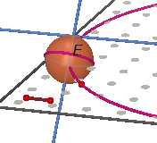

10. A similar construction will give us the boundary between day and night. First use the Segment tool to connect the centres of the Earth and the Sun with a segment.
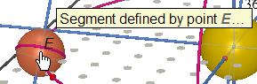

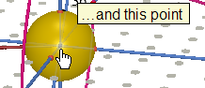

11. Now use the Perpendicular tool to create a plane perpendicular to this segment passing through the centre of the Earth.
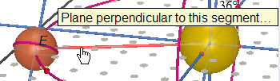

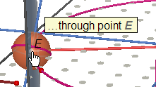

12. Now use the Circle tool (or the Intersection Curve tool) to create the circle at the intersection between this plane and the sphere.
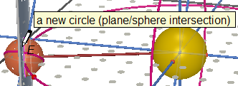

Hide the plane using the right-click menu.
13. As you move the Earth around the Sun, this circle will always face the Sun. The model can already be used to get some idea of the reasons for the seasons. When the Earth’s axis points directly toward the sun, more of the northern hemisphere is in daylight rather than in darkness.
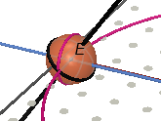

14. We will now create two additional spheres which will give us a more vivid visual model.
First, use the Point tool to create a point on the segment between the Earth and the Sun.
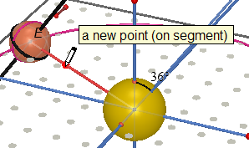

15. Now use the Sphere tool to create a sphere centred on this point and of the same radius as the Earth.
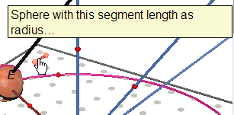

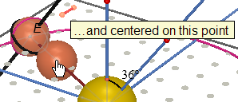

16. We will now use the Central Symmetry (or Reflection in a Point) tool to make a copy of this new sphere on the other side of the Earth.
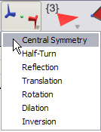

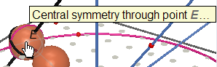

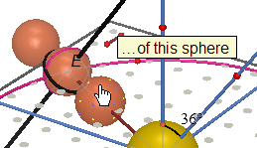

17. We will now hide the original Earth, colour the day/night boundary and the sphere closest to the Sun green and colour the sphere further out black (the equator has also been coloured a lighter gray).
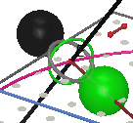

Now move the centre of the green sphere toward point E. Just before you reach point E, the two spheres will appear to be just one
sphere, half black and half green.
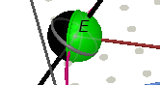

Now hide the centre of the green sphere so that you do not drag it accidentally when you move point E.
You now have a model which shows you visually how the amount of sunlight differs at different times during the year.
18. To add lines of latitude and longitude to the Earth, or to put a point at a particular place on its surface, see the instructions for Modelling the Earth’s Rotation.

