Archimedean Solids

Taken from http://mathworld.wolfram.com/ArchimedeanSolid.html

(all polygons are regular)

Polygons | Name | Picture
triangle  square | cuboctahedron | 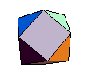
 | small rhombicuboctahedron | 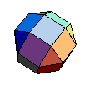
 | snub cube | 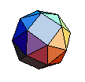
triangle  pentagon | icosidodecahedron | 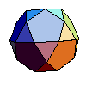
 | snub dodecahedron | 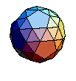
triangle  hexagon | truncated tetrahedron | 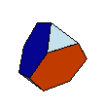
triangle  octagon | truncated cube | 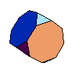
triangle  decagon | truncated dodecahedron | 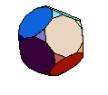
square  hexagon | truncated octahedron | 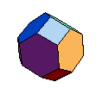
pentagon  hexagon | truncated icosahedron | 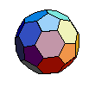
triangle  square  pentagon | small rhombicosidodecahedron | 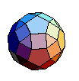
square  hexagon  decagon | great rhombicosidodecahedron | 