Polygon Foldups in 3D

Kate Mackrell
Faculty of Education
Queen’s University
Kingston, ON K7L 3N6, Canada
E-mail: katemackrell@sympatico.ca

Abstract

The software Cabri 3D allows the nets of polyhedra to be constructed using one or more sets of connected polygons where the angle between all connected polygons is the same. These collections can be folded into the polyhedron by dragging a point controlling the angle between the polygons. Viewed from above, the polygons act as a kaleidoscope as the angle changes, and when the angle is decreased so that polygons intersect, surprisingly beautiful symmetric figures emerge, which can be constructed as physical artifacts or experienced as dynamic computer animations.

1. Introduction: an unusual dodecahedron construction

At the T³ conference In February 2005 I watched Jean-Marie Laborde perform an extraordinary dodecahedron construction using the relatively new software Cabri 3D [1], based on the work of Schumann [2]. The outline of this construction is given in Figure 1 below. See [3] for a reference to a website containing a movie which demonstrates the construction in detail.

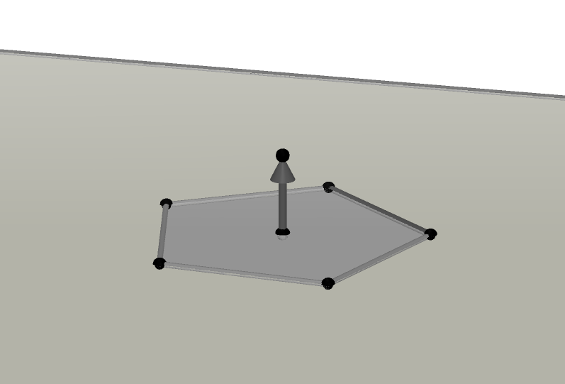 | 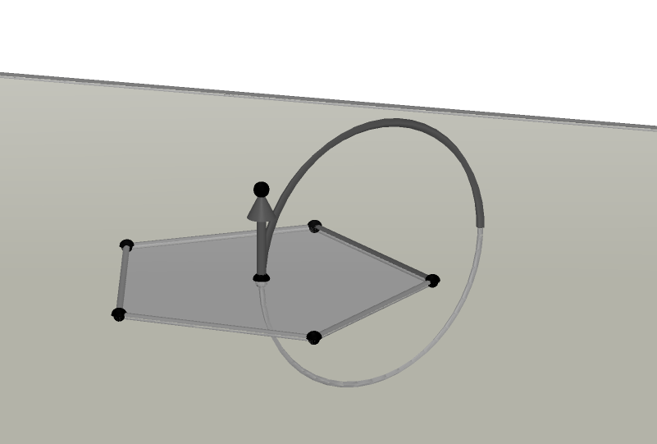 | 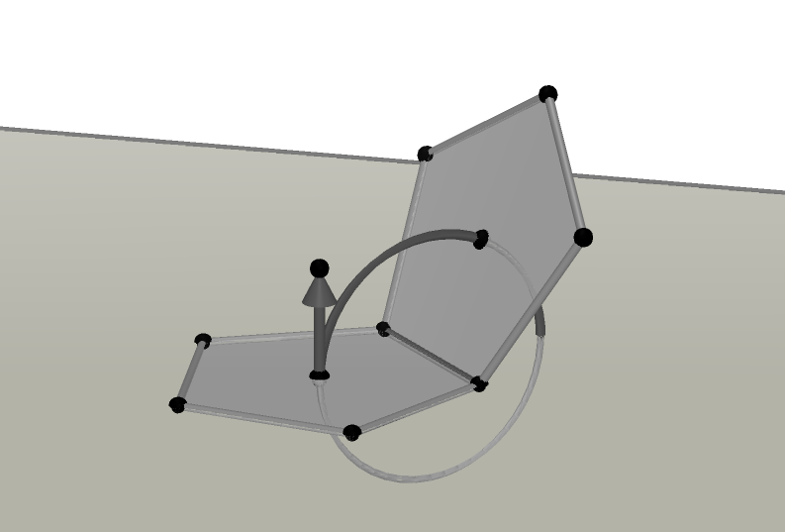
A regular pentagon in a plane, with a segment constructed on one side. | A circle with the segment as axis passing through the centre of the pentagon. | A second pentagon, formed by rotating the original pentagon about the segment, with angle determined by the centre of the pentagon and a point on the circle.
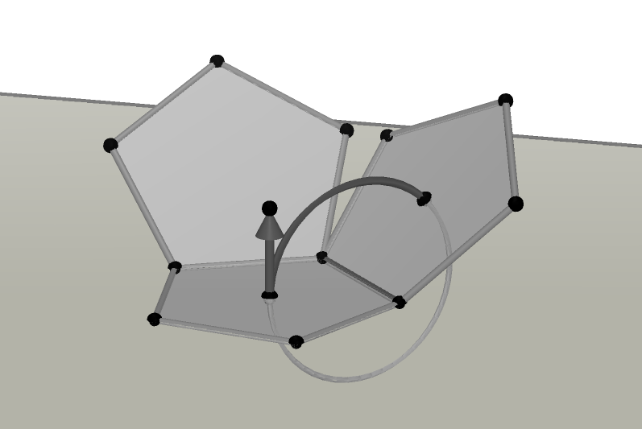 | 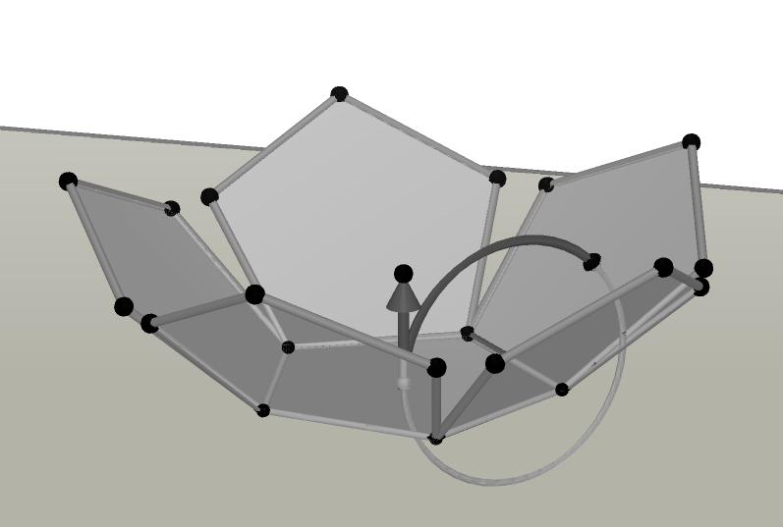 | 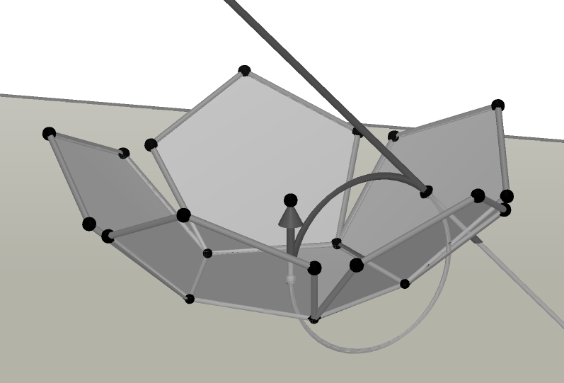
A third pentagon, formed by rotating the second about the central vector. | Three further pentagons similarly created. | A line perpendicular to the second pentagon drawn through its centre.
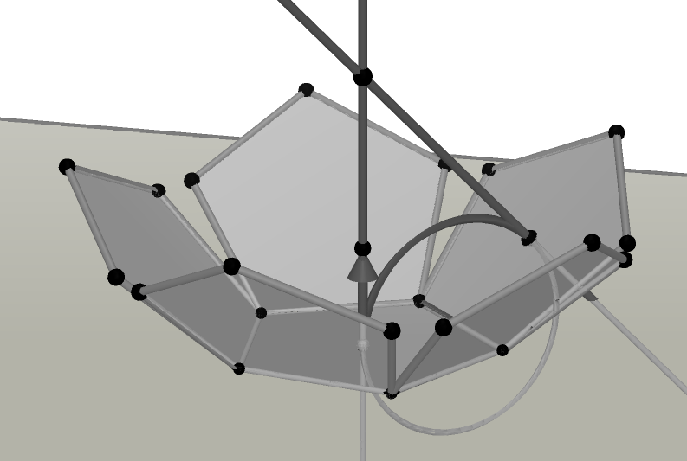 | 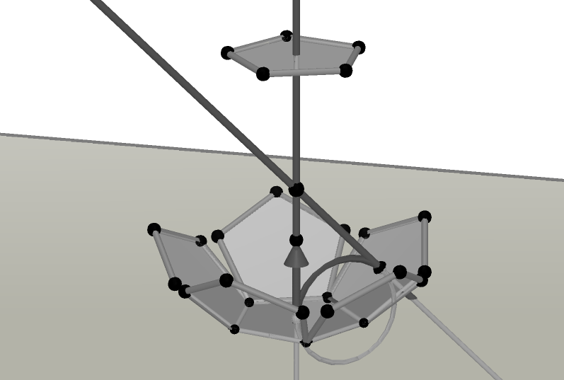 | 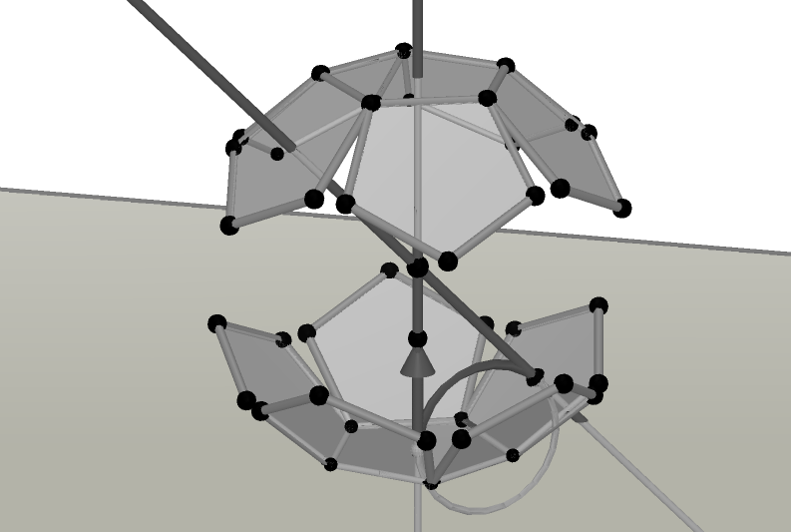
The intersection between this line and the line lying along the central vector. | Reflection of the base pentagon in this point. | Reflection of all other pentagons in this point.

Figure 1: Construction of a dodecahedron net.

This construction is pleasing in itself, both mathematically in that it uses the central symmetry of the dodecahedron, and artistically in that a net with high symmetry results. However, the most intriguing aspect of this net is its behaviour when “folded” by dragging the point on the circle as shown in figure 2 below:

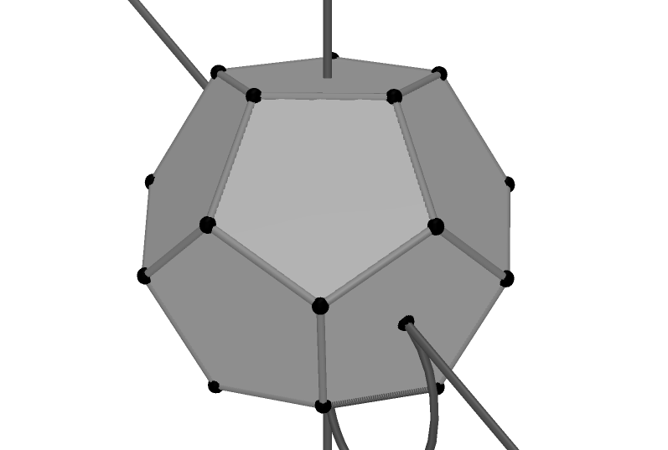 | 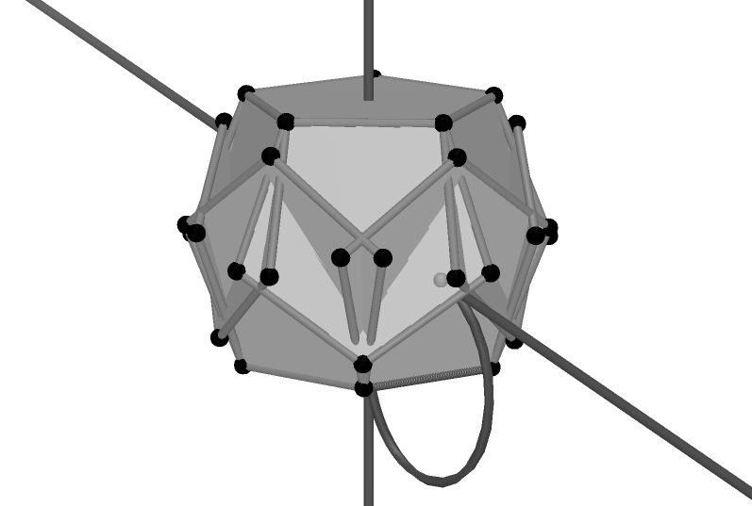 | 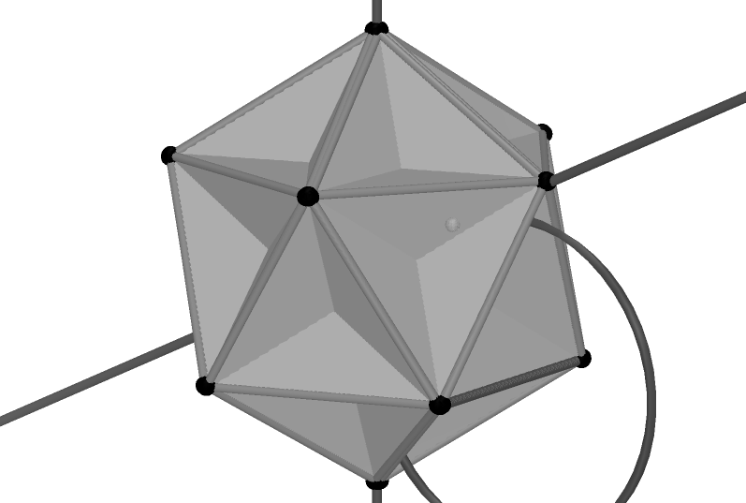
As expected, the dodecahedron emerges. | The dihedral angle can be decreased further so that the pentagons overlap. | The great dodecahedron which then emerges is as unexpected as it is beautiful.

Figure 2: Folding the net.

The collection of pentagons shown above is an example of what I will call a foldup which is defined to be a collection of connected polygons in which all dihedral angles between pairs of joined polygons are equal. The foldup above has two parts, but foldups in general may have any number of parts up to the number of polygons used. A gathering is defined to be a special state of a foldup in which the dihedral angle is such that edges and/or vertices of some polygons which are not directly joined coincide. The dodecahedron and great dodecahedron shown above are both gatherings.

2. Questions

Some of the mathematical questions arising out of this construction will be explored very briefly in this section. There is scope for much more extensive exploration: there are many more polygons or collections of polygons to explore and many more questions which arise.

2.1. Do gatherings depend on the way in which polygons are connected? There are a large number of ways in which nets can be configured. For example, the cube, with only six faces has more than ten possible nets consisting only of squares. An alternative construction of a dodecahedron net (starting from step 7 of the construction above) is given below:

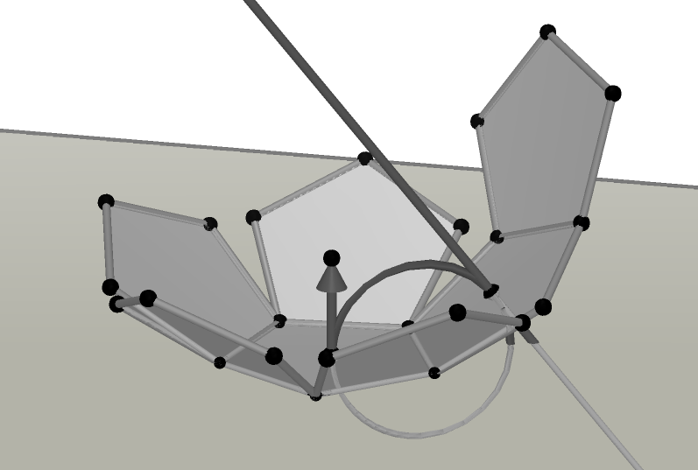 | 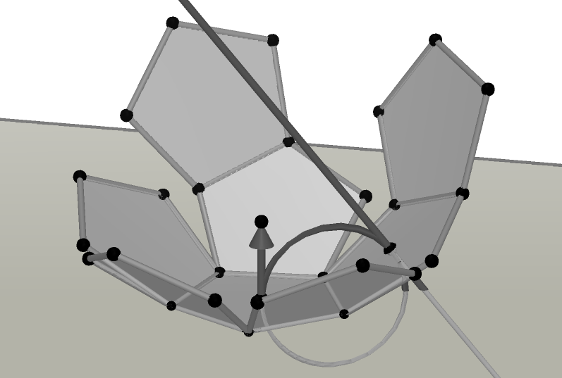 | 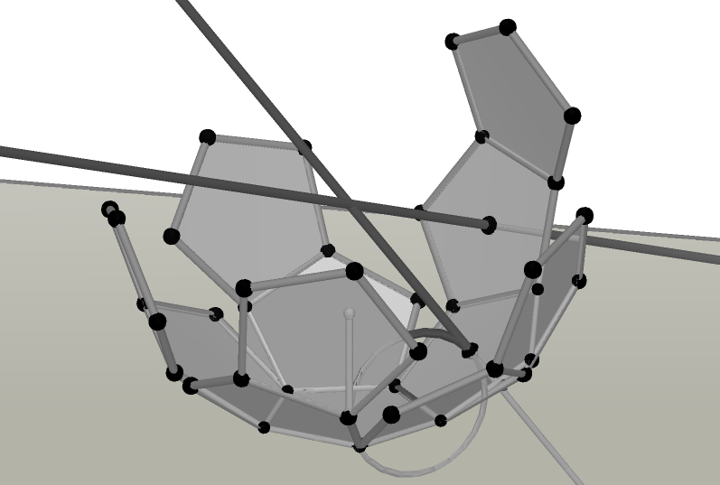
The base pentagon is rotated around the line. | The new pentagon is rotated about the central vector. | A further axis of rotation is created and the second pentagon created is rotated about this axis.

Figure 3: An alternative dodecahedron net.

This foldup does not share all the gatherings of the first pentagon foldup:

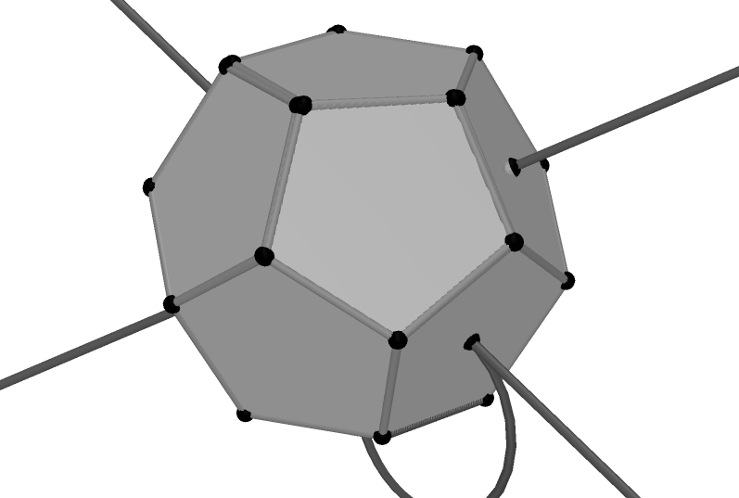 | 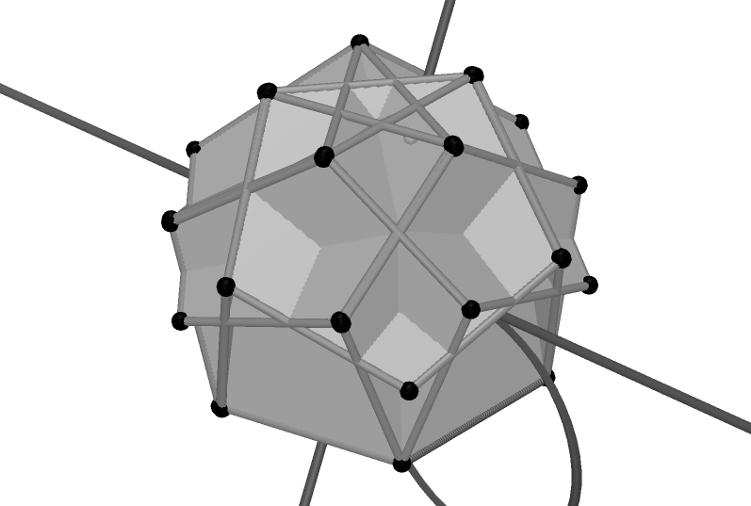 | 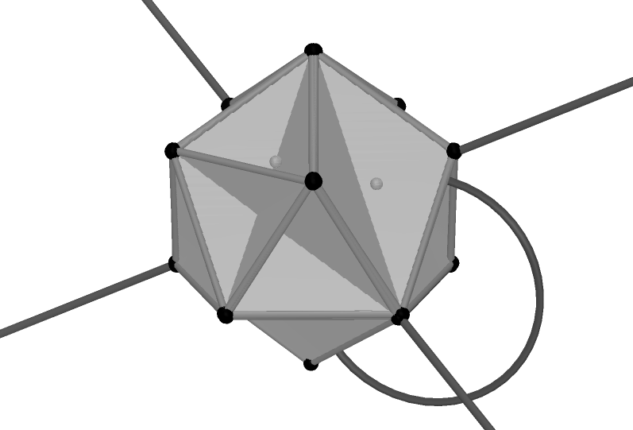
The dodecagon is common to both. | A new gathering. | The great dodecahedron does not emerge.

Figure 4: Gatherings of the alternative dodecahedron net.

2.2. What happens when the nets of other Platonic solids are folded? An icosahedron net can be constructed using a combination of the techniques for the two pentagon foldups shown above. This net, together with two of its gatherings is shown in Figure 5 below.

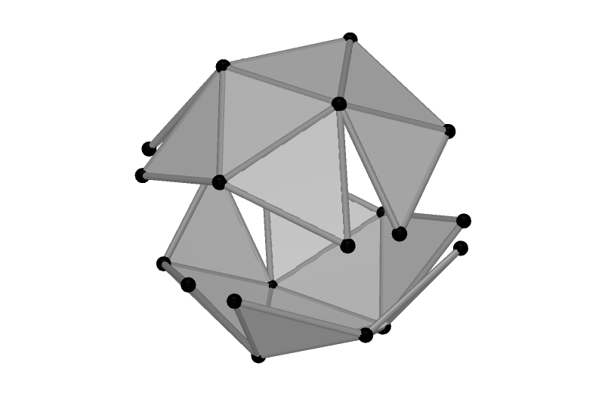 | 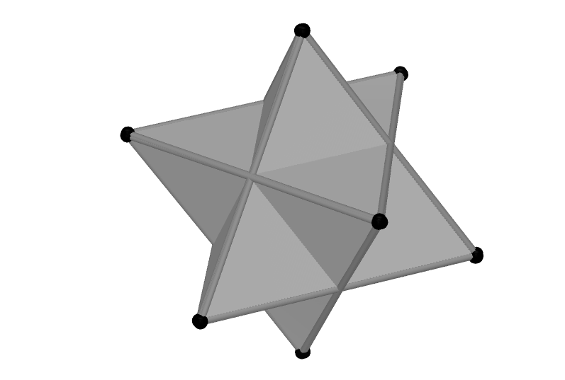 | 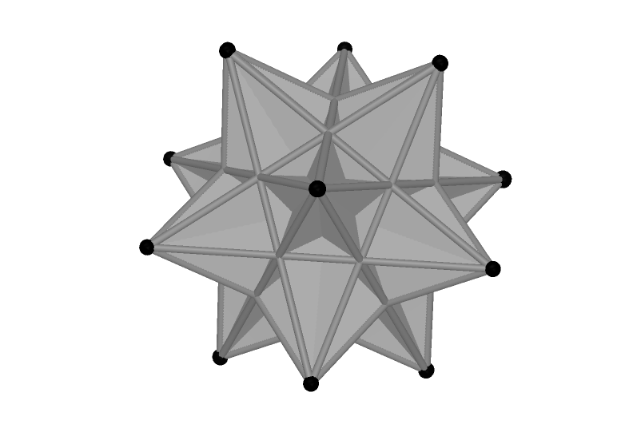
The net | Stella octangula | Great icosahedron

Figure 5: Some of the shapes that emerge as an icosahedron net is folded.

2.3. What happens when the nets of non-regular polyhedra are folded? Figure 6 on the next page shows one way to construct the net of a truncated dodecahedron. In this construction, in order to keep dihedral angles equal, no two triangles or decagons can have adjoining edges.
:
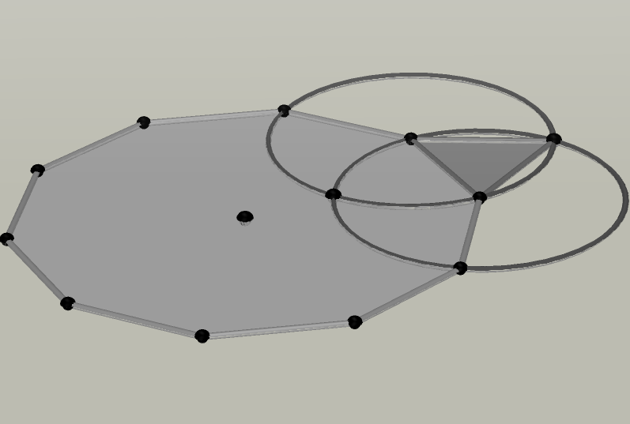 | 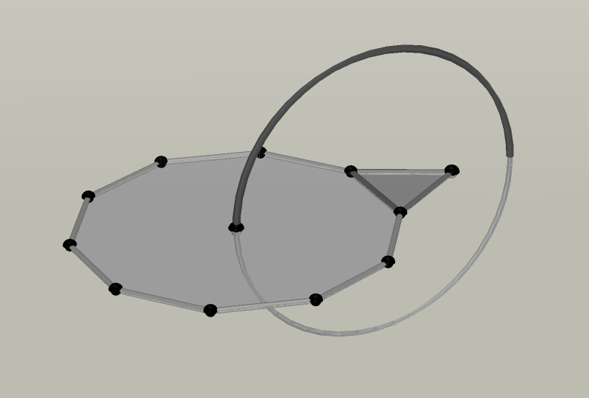 | 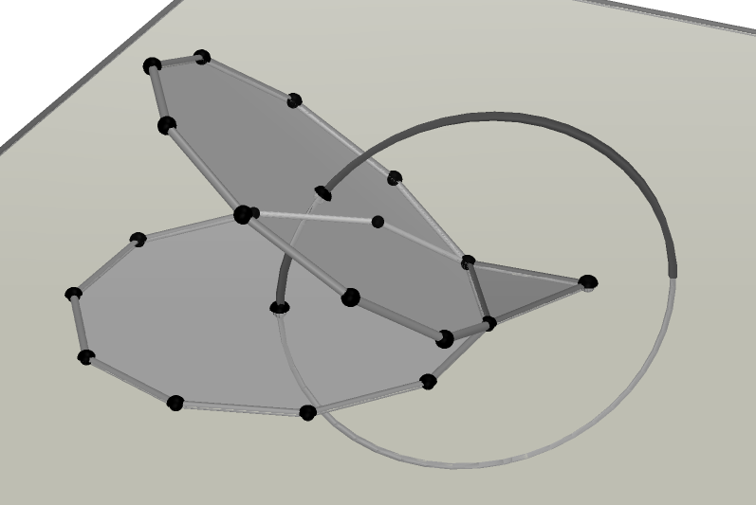
A regular decagon with an equilateral triangle constructed on one side | A circle, with axis the segment between the decagon and the triangle. | A second decagon, rotation of the first about the segment.
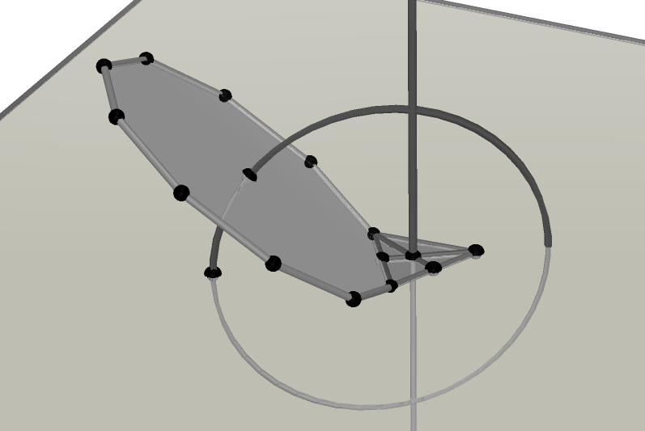 | 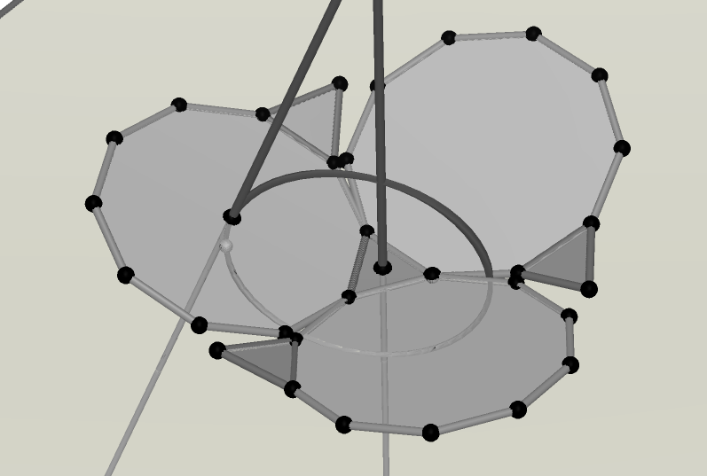 | 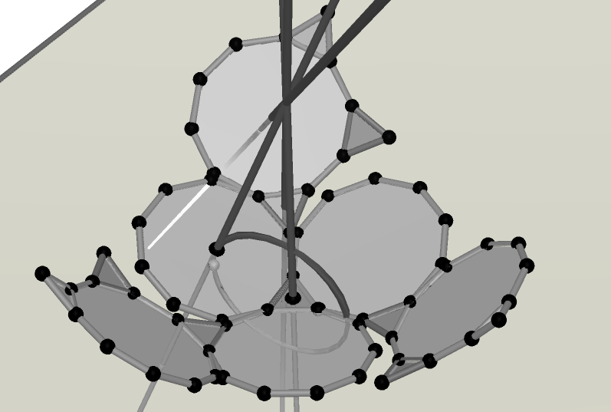
The first decagon is hidden and the line perpendicular to the triangle through its centre is constructed. | Further decagons and triangles are created by rotation. | Here is half of the net: the other half is obtained by reflecting these polygons in the point where the lines intersect
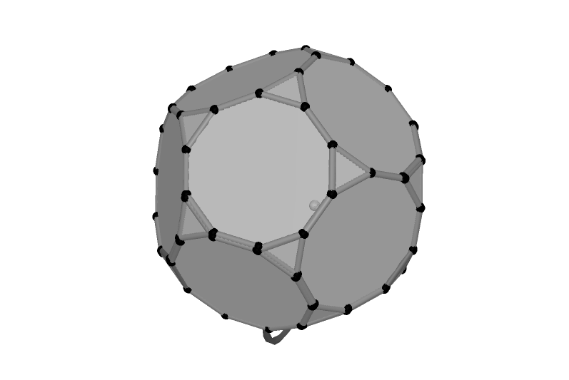 | 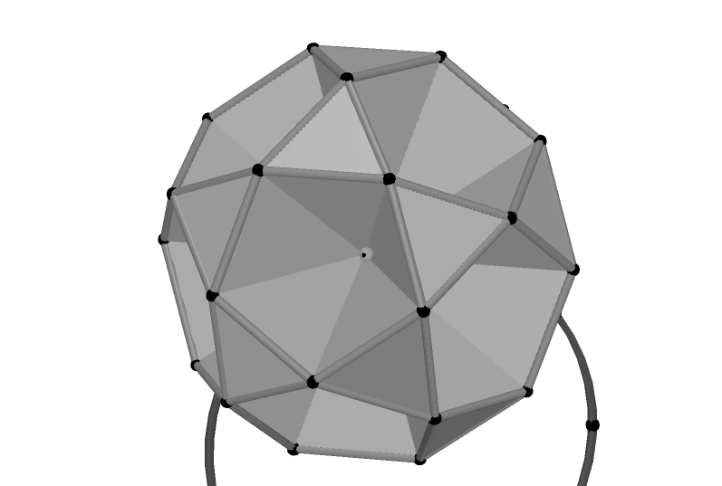 | 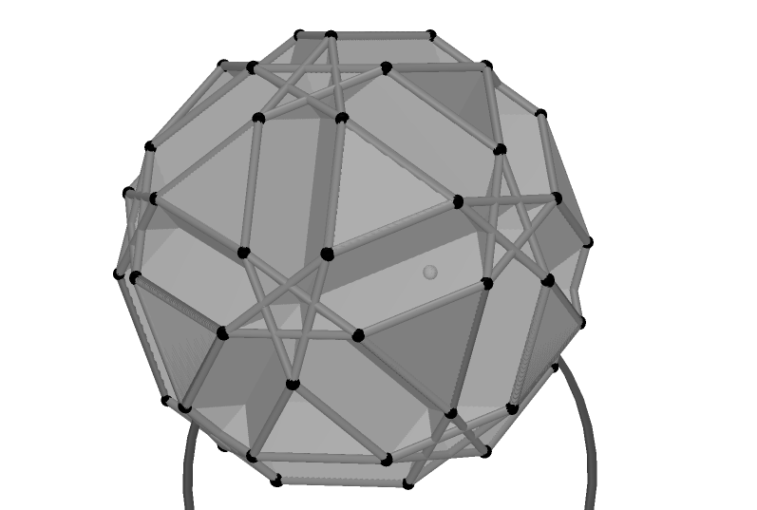
The truncated dodecahedron. | A further gathering. | A further gathering.

Figure 6: Construction of a foldup which forms a truncated dodecahedron.

2.4. What happens if a foldup is not the net of a polyhedron? An example follows.

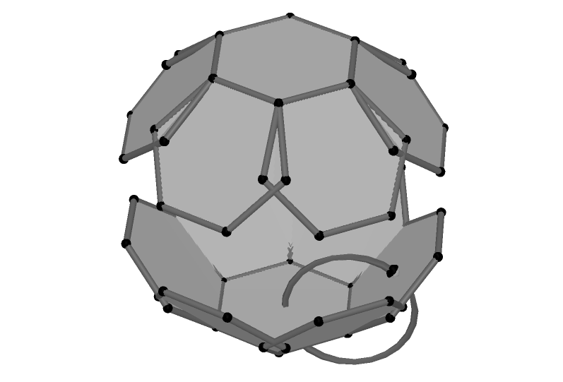 | 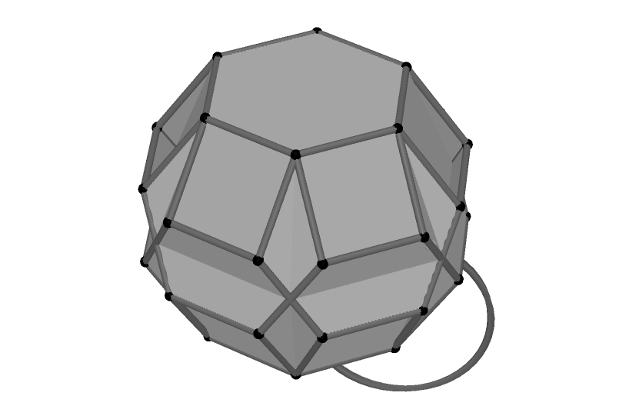 | 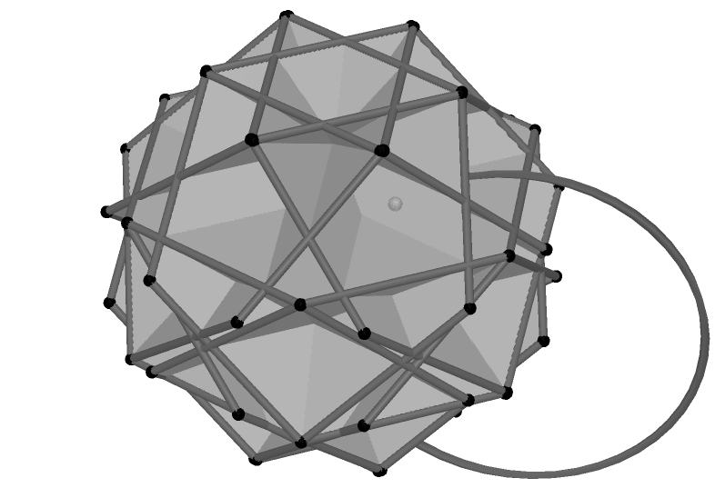
A hexagon foldup constructed the same way as the first pentagon foldup. | This foldup is not a net, but does have gatherings. | A second gathering.

Figure 7: Gatherings of a hexagonal foldup that is not a net.

2.5. Why do gatherings occur? The diagrams below in Figure 8 show the progressive folding of a foldup consisting of five regular nonagons arranged in a ring. These hint at the reasons that particular gatherings occur.

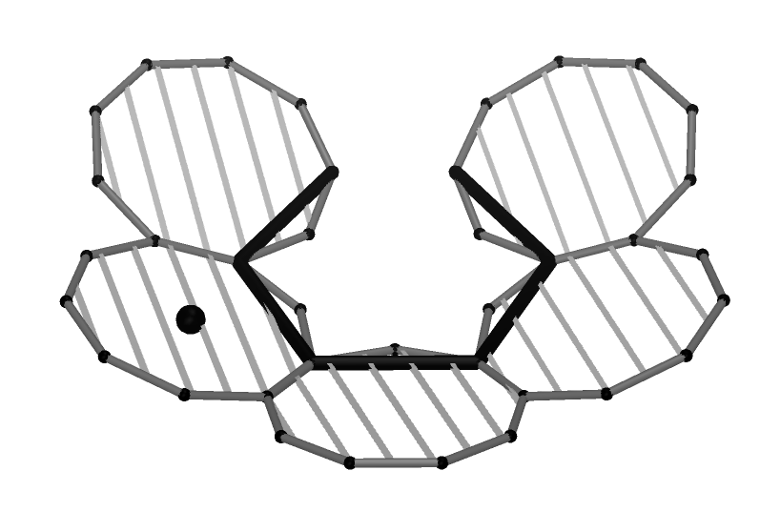 | 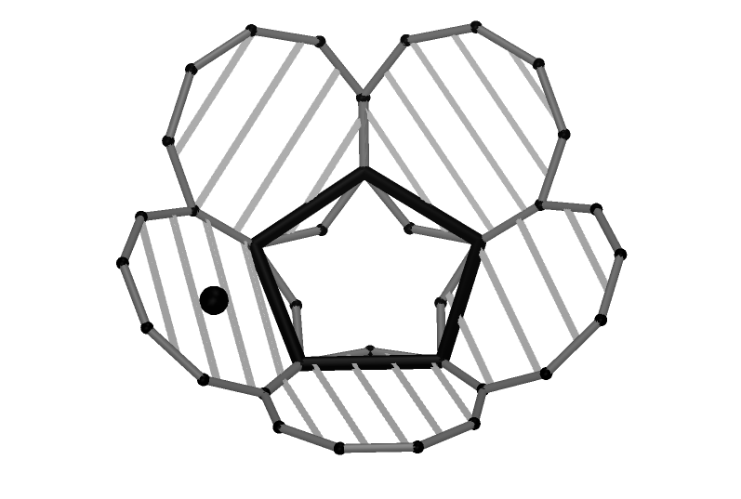 | 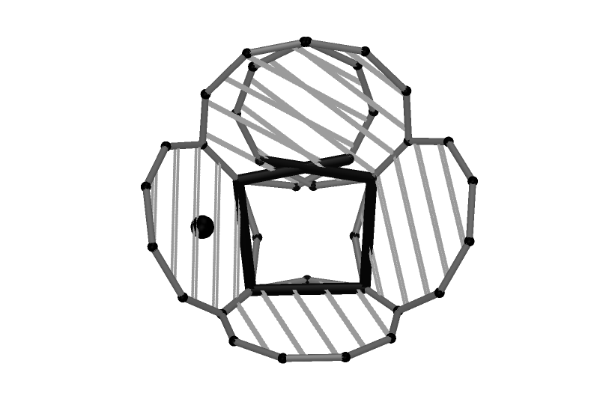
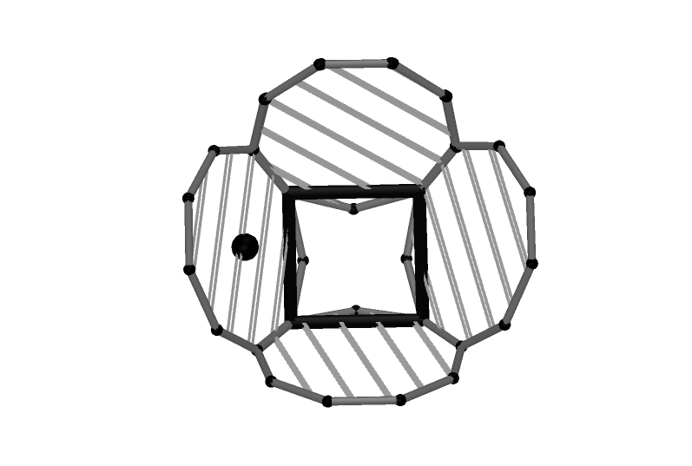 | 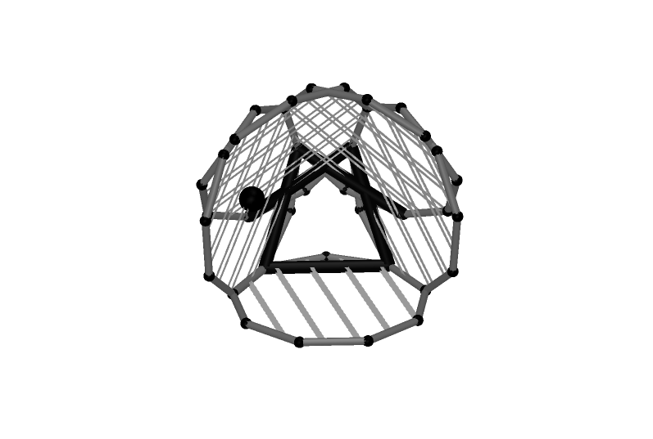 | 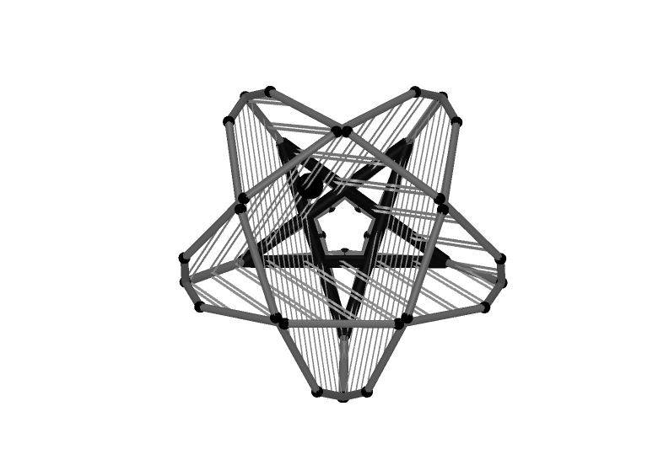

Figure 8: Some indication of why gatherings occur.

2.6. Which gatherings form polyhedra? Some gatherings are polyhedra, such as the great dodecahedron formed by the first pentagon foldup. Many other gatherings, however, appear to be polyhedra until examined closely, when, as with the gathering of the truncated icosahedron in figure 9 below, it is clear that not all edges meet other edges. A further question is whether the foldup can be changed in any way so that gatherings become polyhedra.

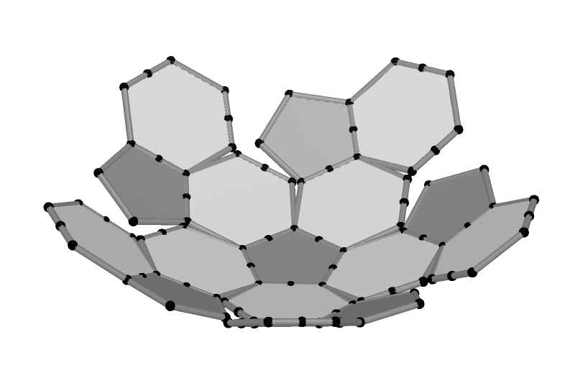 | 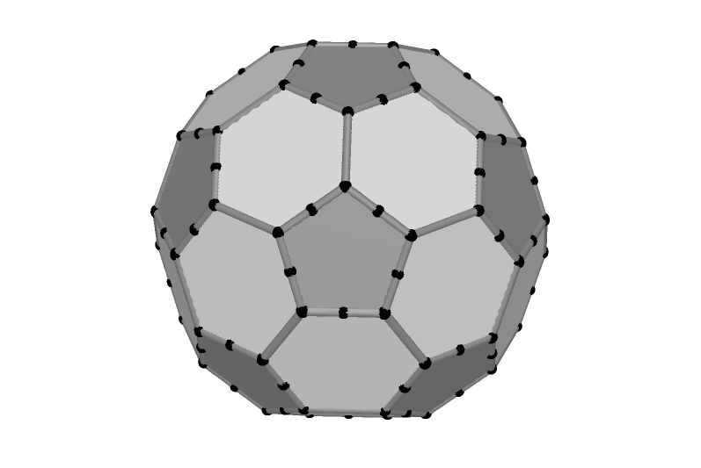 | 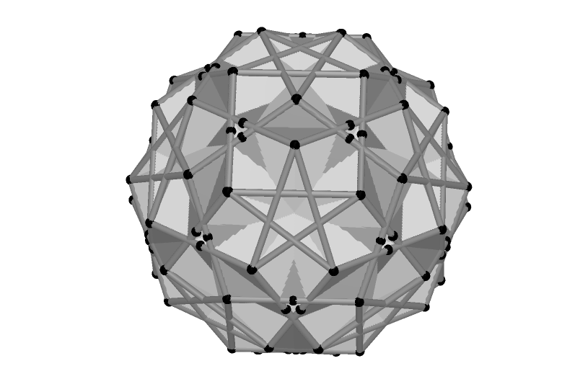
Half of a foldup for a truncated icosahedron. | The truncated icosahedron – a football. | A further gathering of the foldup, which appears to be a polyhedron.
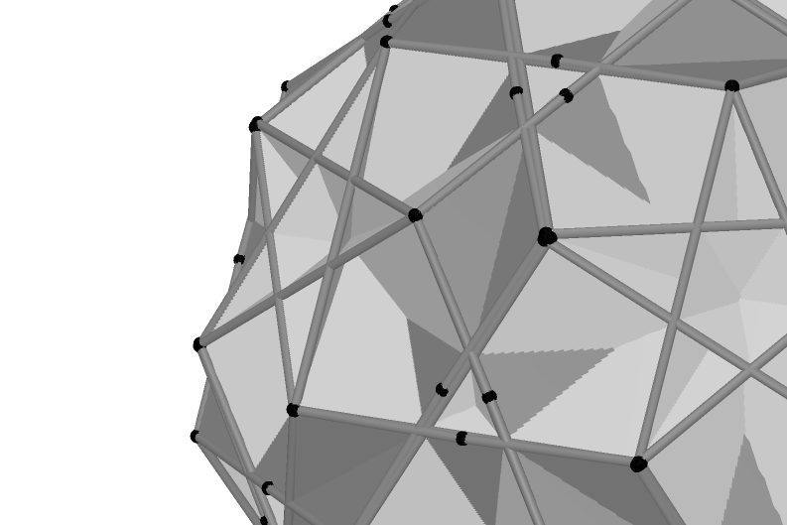 | 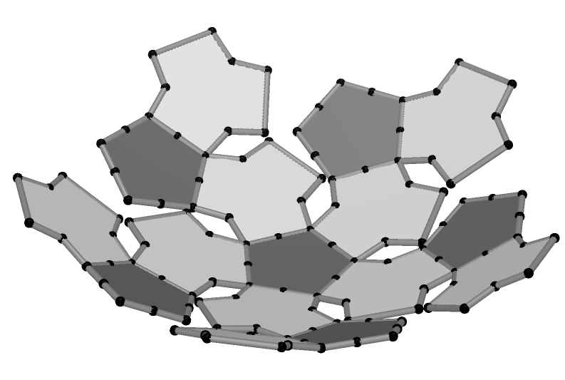 | 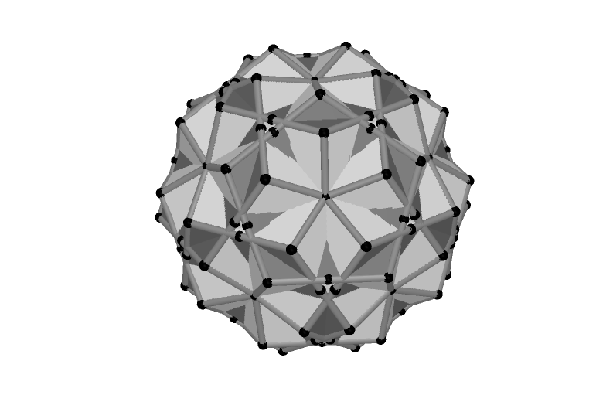
A closeup reveals that polygons do not meet at the edges of the star. | The foldup can be modified by “pruning” isosceles triangles from all hexagons as shown. | The resultant gathering is a polyhedron.
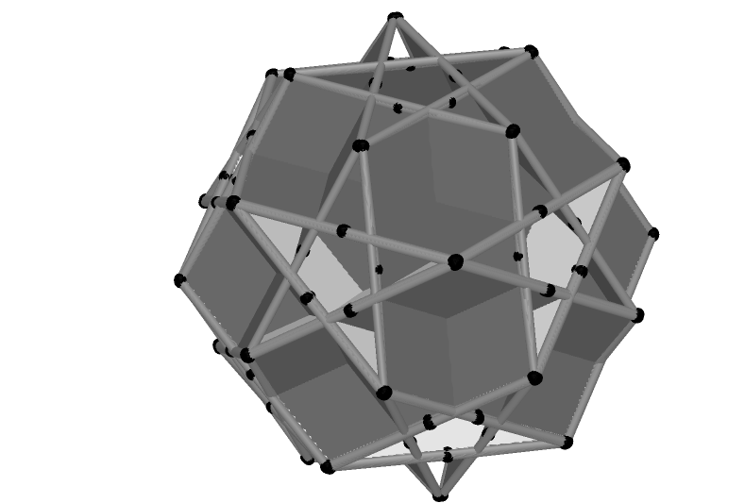 | 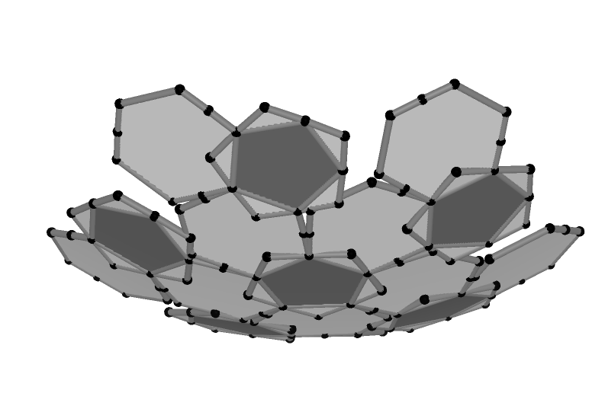 | 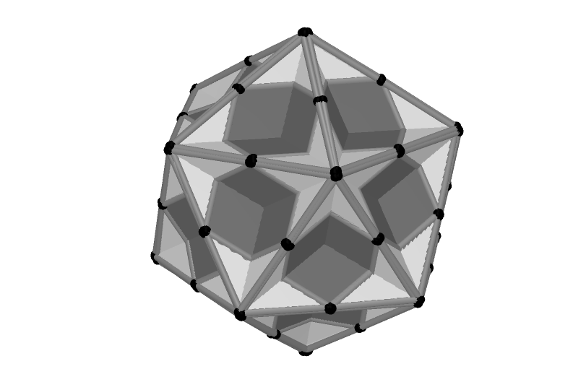
A second gathering of the original foldup which is not a polyhedron. | This time, isosceles triangles are “grafted” onto the pentagons as shown. | The resultant gathering is a polyhedron (the great dodecahedron).

Figure 9: Gatherings and polyhedra.

2.7. What happens when a foldup contains irregular polygons? One among many possibilities to explore is Erdely’s [3] spidron, which consists of two infinite sequences of equilateral and isosceles triangles as shown below. The process by which the spidron is constructed has been used to create a foldup which is the beginning of a fractal.

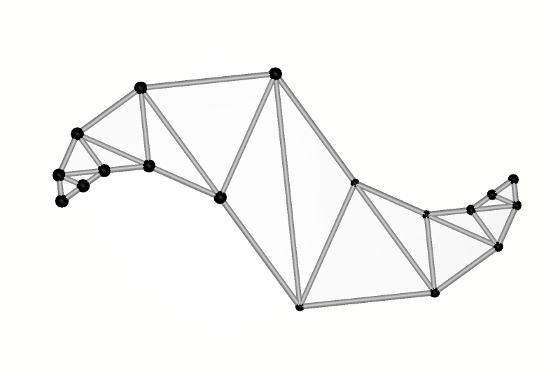 | 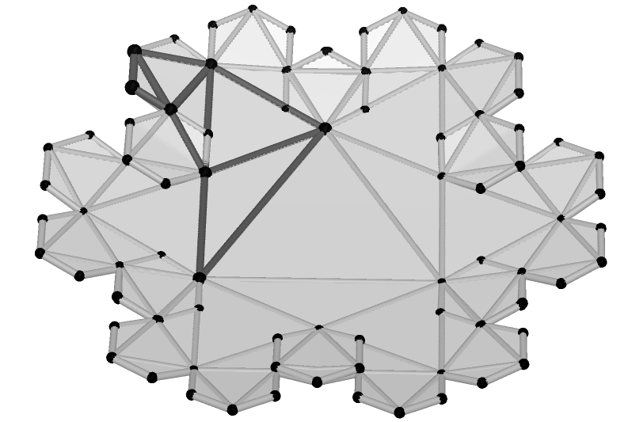 | 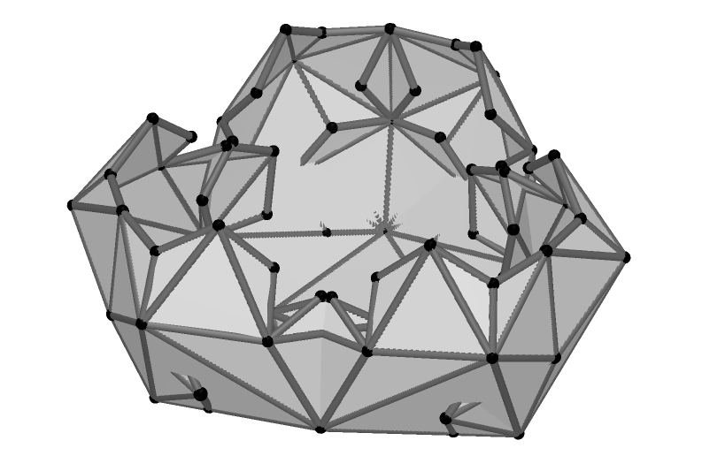
The beginning of a spidron. The sequences continue with triangles of decreasing size. | The beginning of a spidron fractal. The spidron is outlined in black. | A gathering of the fractal.
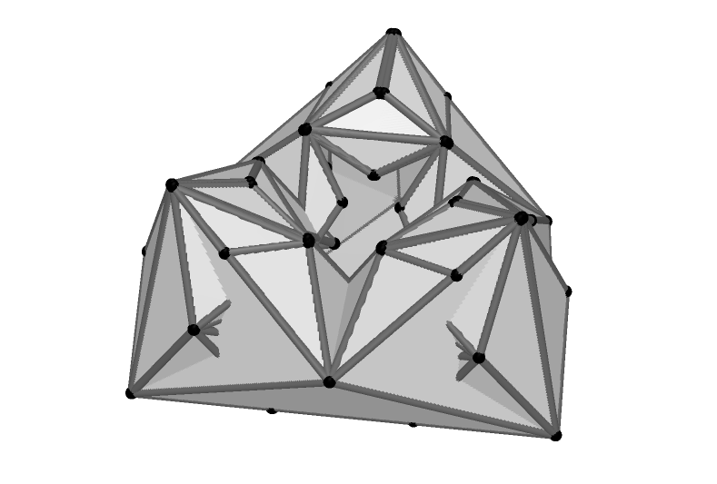 | 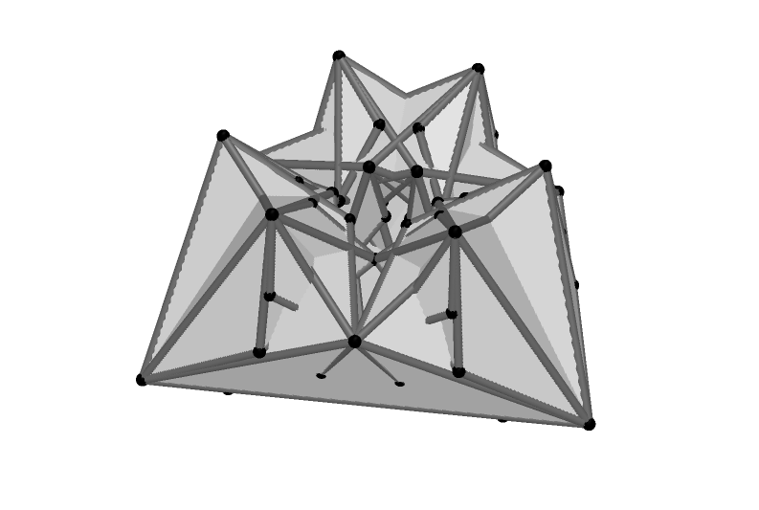 | 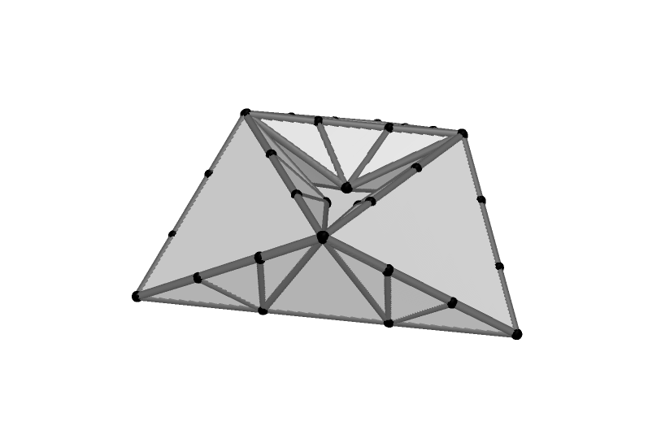

Figure 10: A spidron “fractal” with gatherings.

2.8. What happens when foldups are created to form a stellation of a polyhedron? As the gatherings of the dodecahedron net and icosahedron net include a stellation of the dodecahedron and of the icosahedron, I decided to find out what would happen with a foldup which was deliberately designed to fold to create the great dodecahedron. This foldup is formed from a number of pentagons with pentagrams cut out as shown in figure 11 on the next page. An interesting further gathering, resembling the great dodecahedron turned “inside out” resulted.

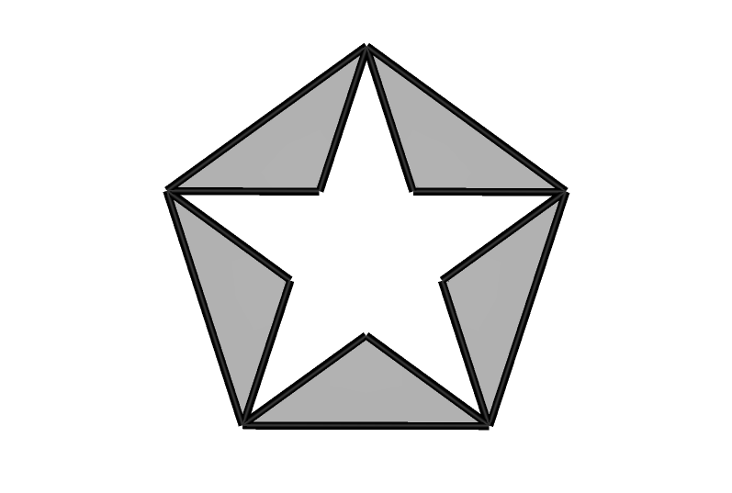 | 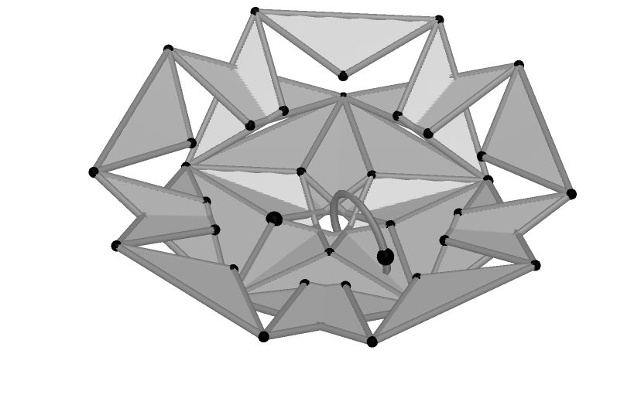 | 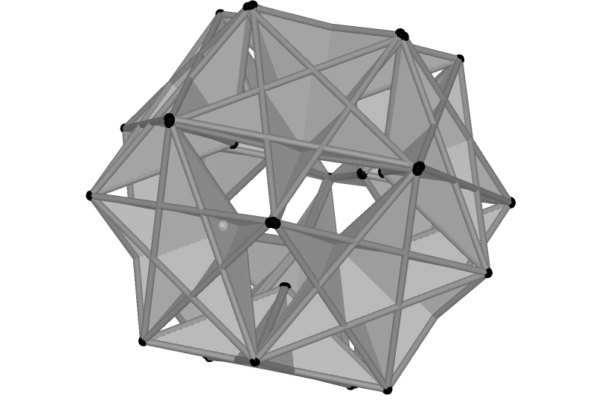
The basic shape for the great dodecahedron foldup. | Half of the foldup. | An “inside-out” great dodecahedron?

Figure 11: A net for the great dodecahedron with a further gathering.

2.9. Further possibilities. Here are a few further ideas to explore.

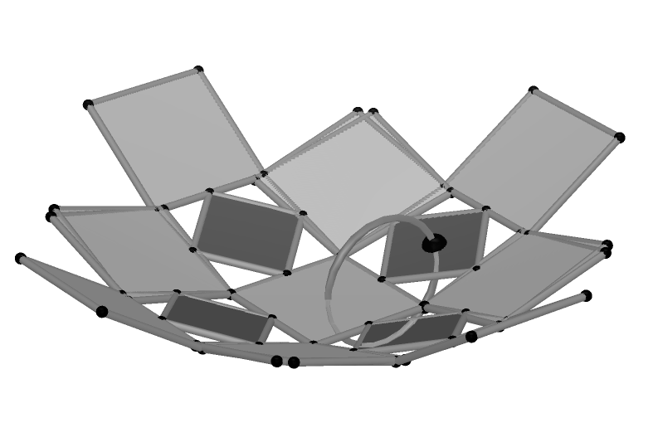 | 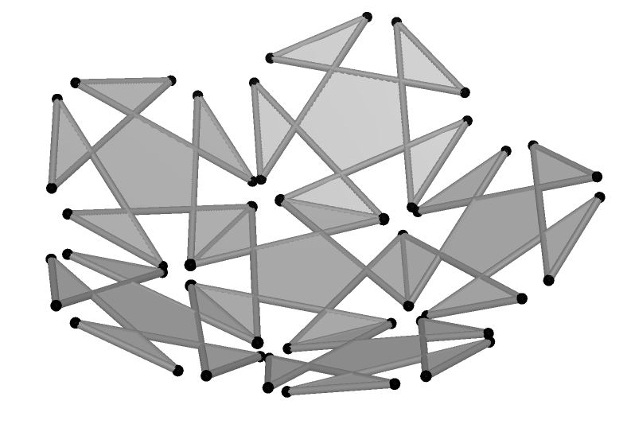 | 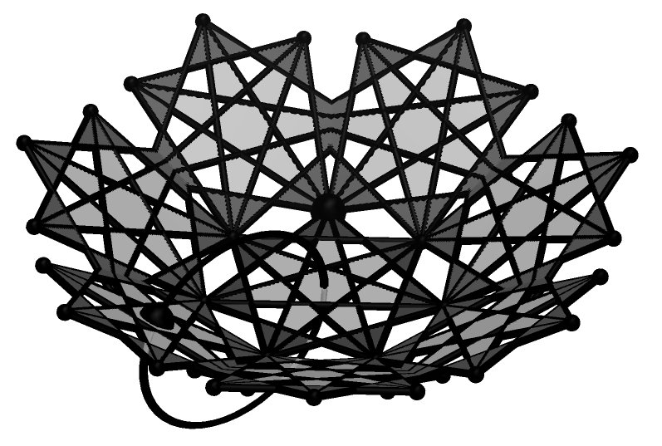

Figure 12: Further possibilities.

Pruning and grafting, introduced in section 2.6, also give rise to further complex and beautiful shapes. In figure 13 below, the truncated icosahedron foldup has first been set to a gathering and then the points controlling the degree of pruning and grafting have been dragged.

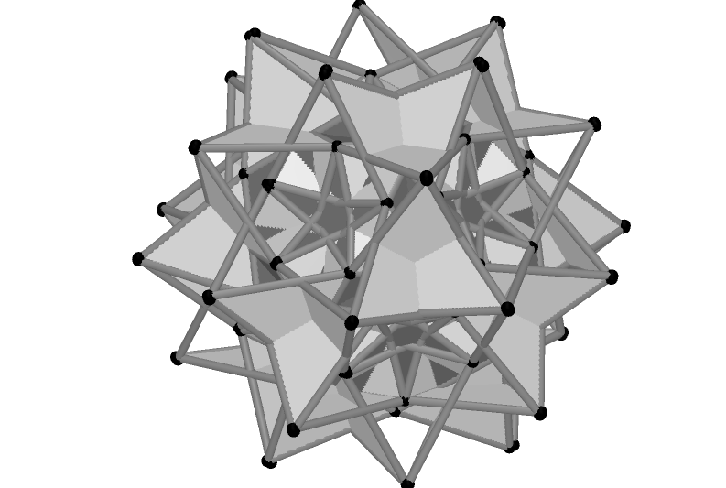 | 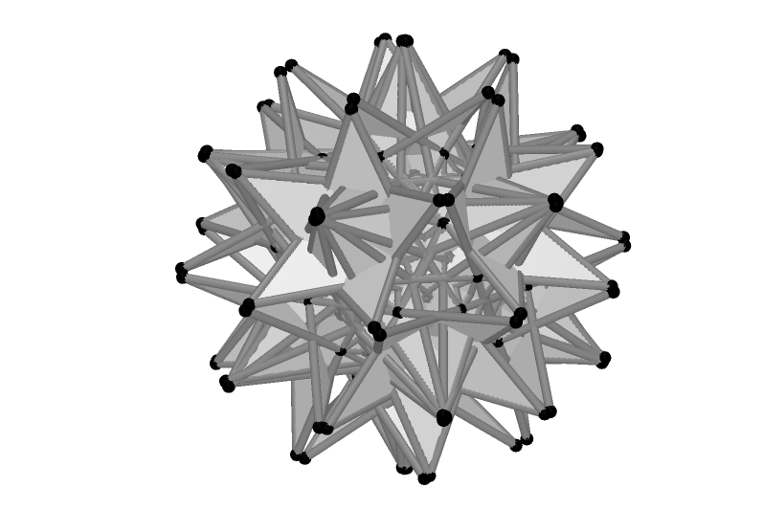 | 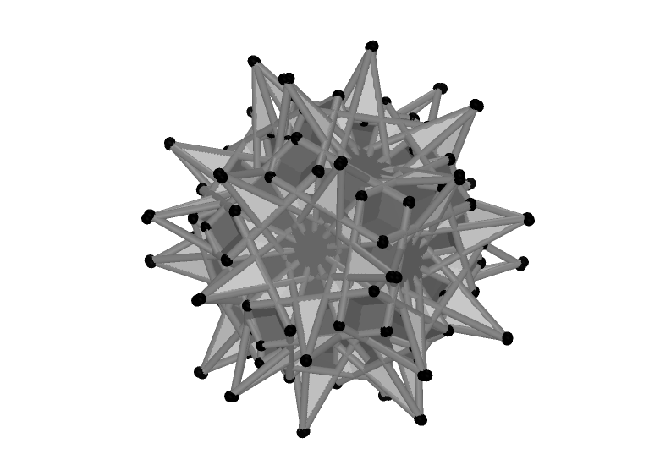

Figure 13: Shapes formed by pruning and grafting a truncated icosahedron foldup.

3. Polygon foldups as art

Hopefully the diagrams here speak for themselves: gatherings give rise to attractive visual images of objects which could be reproduced using physical materials.

The screenshots do not, however, capture the dynamic nature of polygon foldups: the point controlling the dihedral angle may be animated and as this angle changes, the entire configuration changes. Polygons are in constant motion, with little symmetry in the overall figure– until suddenly and unexpectedly a gathering with a high order of symmetry emerges and then disappears. Several dynamic foldups may be experienced at http://educ.queensu.ca/~mackrelk/Cabri3D/polygonfoldups.htm

Foldups may also be viewed looking directly down on the xy plane, and form attractive 2D objects with a high degree of symmetry whether or not the foldup forms a gathering. The pictures below show a number of foldups (none of which are in a gathering) viewed from above:

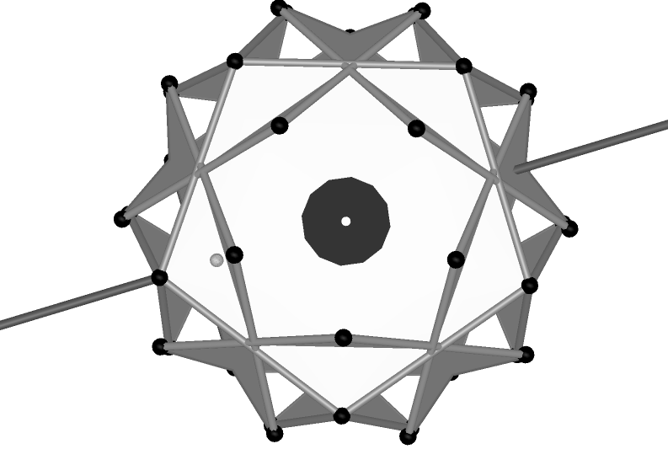 | 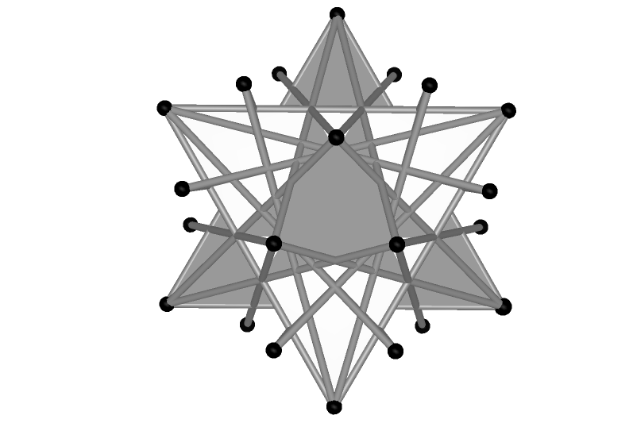 | 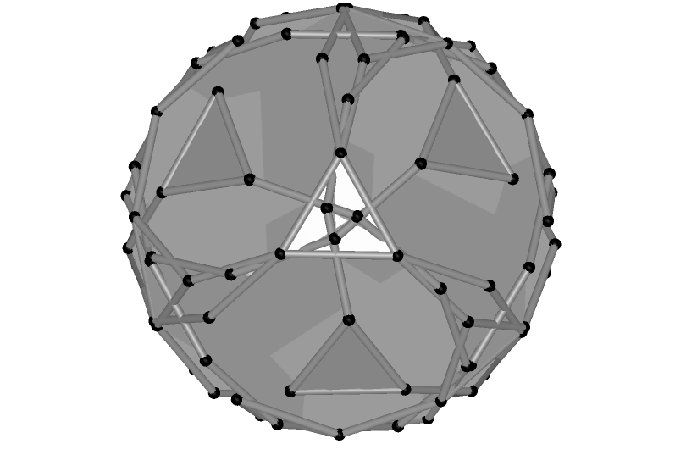
First pentagon foldup. | Icosahedron net foldup. | Truncated dodecahedron foldup – note the rotational symmetry.

Figure 14: Foldups viewed from above.

If the point controlling the dihedral angle is now animated the effect is of a kaleidoscope in which geometric figures are continually changing and symmetry is constantly preserved.

I would also stress that this paper illustrates a very few of the huge number of possible directions for exploration. Most of the shapes used above have been very simple – but the process can be applied to almost any geometric shape, however complex, giving great scope for individual creativity.

4. Conclusion

I would like to make a plea regarding polygon foldups. As far as I am aware, this is a new and potentially rich area of mathematical exploration. This is also an area of mathematics which is both accessible to school students and visually attractive, and this combination is very rare indeed. Could the further exploration of this area hence be left to school students in order that some students have the opportunity to do truly original work in mathematics?

Note: A free 30 day trial version of Cabri 3D can be downloaded from http://www.chartwellyorke.com/cabri3d/demo.html

References

[1] Cabri 3D (Version 1.1) (2005) [Computer Software]. Grenoble, France: Cabrilog

[2] H. Schumann, Konstruktion von Polyedermodellen mit Cabri 3D im Umfeld der platonischen Körper, Beiträge zum Computereinsatz in der Schule, number 2, pp. 3-48. 2004.

[3] http://www.ph-weingarten.de/homepage/lehrende/schumann/geometrie-seite/videoclips.html.

[4] D. Erdely, Spidron System: A flexible space-filling structure. Retrieved October 12, 2005 from http://www.szinhaz.hu/spidron/

