Cabri 3D Tools

Toolbox | Manipulation | Points | Curves | Surfaces | Relative Constructions
Top tool |  |  | 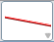 |  | 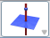
Tools contained |  |  | 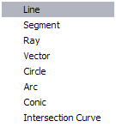 | 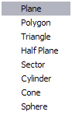 | 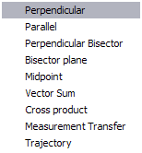
Manual | p 18, 40-41 | p 18 | pp 19-22 | pp 23-25 | pp 26-30

Toolbox | Transformations | Regular Polygons | Polyhedra | Regular Polyhedra | Measurement and Calculation
Top tool |  |  | 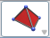 | 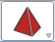 | 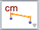
Tools  contained | 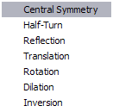 | 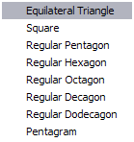 | 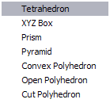 | 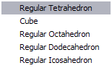 | 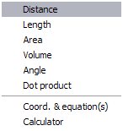
Manual | pp 38 - 39 | p 30 | p 30 - 33 | p 34 | pp 34 - 37

